Test Plan for the MEPAS 4.0 Computed Source Term Release Module

- Background and Scope

The MEPAS Computed Source Term Release Module (CSTRM) is generally the starting module for most analyses because it simulates the contaminant source, outputs contaminant mass fluxes, and links to the other MEPAS-type (Exposure, Vadose, Aquifer, Surface Water, and Air) and non-MEPAS modules (cost, remediation, ecological).

The purpose of the CSTRM is to calculate a set of mass balanced contaminant mass fluxes for radionuclides and chemicals from a source as a function of time. Both radionuclides and chemicals are evaluated by the CSTRM. These contaminant mass fluxes are used to describe the loss of contaminant from the defined source zone via loss routes to various environmental media (i.e., air, soil, and water). Mass balanced source is defined as follows - mass of each contaminant is partitioned to each loss route so the sum of the total calculated contaminant mass losses to all environmental media plus any contaminant remaining in the source (and accounting for contaminant additions/losses through the sink/source term) is limited to 100% of the initial contaminant mass. In some cases, 100% of the contaminant mass will not be lost from the waste zone because the simulation time is reached before all mass is estimated to be loss. The simulation time is a user-defined value ranging from less than a year to 10,000 years.

The loss routes in the CSTRM are water leaching, volatilization, wind suspension, overland runoff, and decay/degradation. These loss routes can contaminate air, water, and soil in the environment around the source. Common source types normally dealt with in hazardous waste site assessment are landfills, buried waste, surface impoundments, surface storage, wastewater outfalls, injection wells, vents/stacks, aquifers, rivers, and lakes/ponds. The three generic source types in the CSTRM are: 1) aquifer, 2) ponds/surface impoundments, and 3) surface/subsurface soil.

The user can have the CSTRM compute all the contaminant mass fluxes for all loss routes or input known contaminant masses fluxes for some loss routes and have the module compute the other loss routes. If the user knows all the contaminant mass fluxes for all loss routes, a separate MEPAS module must be used.

This document describes how the CSTRM was tested to ensure it met its requirements. The document lists the specific requirements, shows how the test cases that follow related to these requirements, describes each test case, and describes the results of running each test case. The test cases address the basic functionality listed in the requirements. The testing plan and results will be used to establish a baseline version of the module. The formulations for this module are provided in Streile et al. 1996.

All testing for this version of the CSTRM was completed successfully except for tests that addressed the computed water balance and the use of multiple organics. Further testing will need to be conducted to ensure that model is performing satisfactorily. Testing to address these issues will be completed for the next version of CSTRM. Users employing the computed water balance or multiple organic compounds in an assessment should examine their results closely.

The module files used in testing are as follows:
AFFTrim.exe 7/10/98
STRM1.exe 8/3/99
Strmui.exe 10/13/99
Mepsrc.des 10/14/99
MepSrc.bat 7/7/98
Strm.htm 8/2/99

(Note: The HTM and GIF files associated with the CSTRM help file are not listed here.)

- Requirements

Requirements for the CSTRM are described in a document entitled Requirements for the MEPAS Source Term Release Module. These requirements were reworded into the following list of concise, fundamental requirements suitable for testing:

Requirement  Number | Requirement
1 | Allow the user to evaluate up to 25 constituents currently in the database in a single run. This requirement ensures that the user is not limited in the number of constituents that can be included in a run
2 | Perform contaminant mass balance calculations associated with each constituent for the entire waste zone
3 | Perform contaminant mass partitioning to the appropriate transport and exposure media via the different release mechanisms (leaching, volatilization, wind suspension, overland runoff, and degradation/decay)
4 | Produce time-varying contaminant mass fluxes for air, water, and soil deposition (from air) from the source zone that meet the data specifications of the FRAMES software system
5 | Produce time-varying contaminant soil concentrations based on the contaminant mass remaining in the source zone that meet the data specifications of the FRAMES software system
6 | Provide a module user interface (MUI) that runs under Windows95 and has a standard Windows95 look and feel
7 | Provide on-line help in an HTML format that provides the user with descriptions of all input parameters required by the MUI
8 | Provide a MUI that allows the user to select different units for the appropriate input parameters
9 | Allow the user to select the environmental media and loss routes associated with the source
10 | Allow the user to provide source characteristics associated with the environmental media and loss routes selected
11 | Allow the user to enter constituents by mass or by concentration
12 | Allow the user to enter required Constituent Properties
13 | Include infiltration, wind and mechanical suspension, volatilization, overland runoff (soil erosion and water flow), and decay/degradation as contaminant mass loss route options
14 | Provide estimated values for Kds based on user input
15 | Compute time-varying water flow rates (infiltration and overland runoff) based on site characterization and meteorological (monthly climatology) data
16 | Compute wind, mechanical, and overland soil erosion rates
17 | Compute contaminant mass fluxes for all specified loss routes or allow the user to input known contaminant mass fluxes for some loss routes and compute the contaminant mass fluxes for the remaining specified loss routes
18 | Output intermediate data files (i.e., SLS) in an ASCII format that echo the input data and provides intermediate calculations and results
19 | Create an error (*.ERR) file in an ASCII format at the start of the module execution
20 | Address chemical and radioactive constituents
21 | Allow time-varying sources and sinks as part of the waste zone loss routes and mass balance calculations
22 | Calculate in-growth of progeny from radionuclide contaminants and consider them in the mass balance and partitioning calculations
23 | Provide time-varying infiltration results in the *.WFF file
24 | Provide a default value for the minimum waste fraction, which is used to determine when the model should terminate a run, that can be modified by the user as necessary
25 | Execute phase distribution calculations for each time step to determine the mass of each contaminant in the four phases (aqueous, soil, vapor, and organic)
26 | Provide an about tab to inform users of the title, version number, and general description of the module
27 | Provide option for user to enter user-defined constituent mass fluxes from the source
28 | Provide the mass flux of contaminant to the air in the *.AFF file and the mass flux of contaminant to the water in the *.WFF file
29 | Provide time-varying contaminant particle and gaseous emission rates in the *.AFF file

The following tables show the relationship between the requirements and the test cases described in Section 3.

Requirement  Number | Test Case Number
Requirement  Number | 1 | 2 | 3 | 4 | 5 | 6 | 7 | 8 | 9 | 10 | 11 | 12 | 13 | 14 | 15 | 16 | 17 | 18 | 19
1 |  |  |  |  |  |  |  |  |  |  |  |  |  |  |  |  |  |  | X
2 |  |  |  |  |  |  |  |  |  |  |  | X |  |  | X | X |  | X
3 |  |  |  |  |  |  |  |  |  |  |  | X |  |  |  |  |  | X
4 |  |  |  |  |  |  |  |  |  | X |  | X
5 |  |  |  |  |  |  |  | X
6 | X
7 |  |  |  |  |  |  |  |  | X
8 | X
9 | X |  |  |  |  |  |  |  |  |  |  |  |  |  |  |  |  | X
10 | X
11 | X |  |  |  |  |  |  |  |  |  |  |  |  |  |  | X | X
12 | X
13 | X
14 |  |  |  |  |  |  |  |  |  |  |  |  |  |  |  | X
15 | X | X | X | X | X | X | X
16 |  |  |  |  |  |  |  | X | X
17 |  |  |  |  |  |  |  |  |  | X | X | X
18 |  |  |  |  |  |  |  | X
19 | X
20 |  |  |  |  |  |  |  |  |  | X
21 |  |  |  |  |  |  |  |  |  |  |  |  |  | X
22 |  |  |  |  |  |  |  |  |  |  |  |  | X
23 |  |  |  |  |  |  |  |  |  |  |  |  |  |  |  |  |  |  | X
24 | X
25 |  |  |  |  |  |  |  |  |  |  |  | X
26 | X
27 |  |  |  |  |  |  |  |  |  |  |  |  |  | X
28 |  |  |  |  |  |  |  |  |  |  |  | X
29 |  |  |  |  |  |  |  |  |  |  |  | X

- Test Cases and Baseline Testing Results

All of the following tests were executed using the MEPAS 4.1 CSTRM. The description and rationale for each test case is stated along with the input data required, expected results, procedure for conducting the test, and the output results of the test.

General instructions for setting up and running each test case are located in Appendix A. Specific instructions required for running each test case will be described in the test case summaries that follow.

Default parameter values used for the test cases are listed in Appendix B. Each test case will require at least minor changes to these default parameter values. The necessary changes will be specified in each test case description.

3.1 Tcase01

3.1.1 Description and Rationale

This case verifies that the CSTRM correctly calculates an infiltration and overland runoff rates based on varying monthly climatological and site data. Climatology data was entered that described a site that on average had one adequate wet season per year. The constituent Chromium VI was selected for this case.

Because this is the first test case, several other CSTRM requirements will be addressed through this case. This case will verify that the CSTRM meets the following requirements:

- Provides a module user interface (MUI) that runs under Windows95 and has a standard Windows95 look and feel
- Provides a MUI that allows the user to select different units for the appropriate input parameters
- Allows the user to select the environmental media and loss routes associated with the source
- Allows the user to provide source characteristics associated with the environmental media and loss routes selected
- Allows the user to provide source characteristics associated with the environmental media and loss routes selected
- Allows the user to enter required Constituent Properties
- Includes infiltration, wind and mechanical suspension, volatilization, overland runoff (soil erosion and water flow), and decay/degradation as contaminant mass loss route options
- Provides a variable time step for evaluating mass loss (default is 1 year)
- Provides a default value for the minimum waste fraction, which is used to determine when the model should terminate a run, that can be modified by the user as necessary

The above requirements are basic functions of the CSTRM that will need to be met by all test cases, however, they will only be checked specifically in this test case. Going through the process of setting up the test case will check all of these requirements.

3.1.2 Input Data

The default input data for this case is listed in Appendix B. Several changes were made to the default parameters listed. The parameter ‘leaching’ was changed from ‘turn off pathway’ to ‘compute pathway’ and the parameter ‘STMAXTIME’ was changed to 5 years on the Options tab. The parameter ‘total porosity’ was changed to 44%, and ‘moisture content’ was changed to 20% on the Waste Zone tab. The additional input data required are listed below.

The following table lists the input data required for the Monthly Climatology tab.

Months | STTEMP (C) | STMPRECIP (cm) | STWINDV (m/s) | STCLOUD (tenths) | STMNUMPRE (days) | STRHMIN (%) | STRHMAX (%)
Jan | -3.8 | 12.80 | 4.2 | 6 | 14 | 77 | 80
Feb | -4.1 | 10.40 | 3.4 | 7 | 13 | 71 | 80
Mar | -1.0 | 8.79 | 2.2 | 7 | 16 | 69 | 81
Apr | 3.2 | 7.95 | 2.6 | 7 | 13 | 64 | 83
May | 7.1 | 6.20 | 2.5 | 9 | 16 | 65 | 89
Jun | 10.6 | 5.41 | 2.4 | 7 | 14 | 67 | 91
Jul | 12.8 | 10.00 | 1.9 | 7 | 17 | 74 | 94
Aug | 12.3 | 9.45 | 1.7 | 6 | 17 | 75 | 96
Sep | 8.7 | 21.00 | 1.9 | 7 | 19 | 74 | 91
Oct | 3.8 | 23.20 | 2.7 | 8 | 21 | 79 | 86
Nov | -1.3 | 15.20 | 2.9 | 7 | 15 | 78 | 83
Dec | -6.1 | 13.60 | 3.6 | 7 | 15 | 74 | 78

The following table lists the input data required for the Hydrology tab.

Parameter | Value | Unit
STLCDELEV | 37.00 | Ft
STLAT | 61.12 | Deg
STELEV | 37.00 | Ft
STSCSCN | 88 | none
STAVAILW | 6.04 | cm
STNUMPRCP | 190 | none

The following table lists the input data required for both the Kd’s and Constituent Properties tabs.

Parameter | Value | Unit
STKD | 0.0 | ml/g
STSOL | 1.00E+06 | mg/L
STINVEN | 1.0 | g

3.1.3 Expected Results

Hand calculations were performed to estimate the infiltration rate that the CSTRM will compute. The hand calculated value for infiltration rate is 92.855 cm/yr. In addition it is expected that all of the requirements listed in section 3.1.1 will be met.

3.1.4 Procedure

Instructions for running this case can be found in Appendix A. Save this case as tcase01.gid. As noted above, use the default parameter values provided in Appendix B unless otherwise instructed. The additional input data required are listed in section 3.1.2. A WFF viewer should be added for to view the results.

In addition to this, 1) note the UI layout to verify that it has a standard Windows look and feel and 2) verify that the module has an about tab with the appropriate information. To check the about tab, open up the UI and click on the Help menu. Select ‘About’ and the about MEPAS CSTRM window should appear. Check that all required information is presented and then close down the window and FRAMES.

3.1.5 Results

The CSTRM met all of the requirements listed in section 3.1.1. The infiltration rate calculated by the CSTRM can be determined using the output in the WFF file, which is listed below. The value computed for infiltration can be compared with the expected result listed above.

Tcase01.WFF

"src2",0000000020
7,
"=============================================================================",
" Source Term Release Module Version: Framework PoP January 1997 ",
" Run:","D:\FUI\~glyph",
" Site:","src2",
" Run Performed:","3/22/1999","10:51:44",
" Output Filename:","D:\FUI\~glyph.wff",
"=============================================================================",
1,
"src2","Vadose",10,"m",10,"m",0,"m",0.7018902302,"m/yr",1,
"yr","m^3/yr",2,
0,70.18902588,
5,70.18902588,
"Chromium VI","7440473","yr","g/yr", 6,1,0,
0,0,
1,0.0027633477,
2,0.002755722031,
3,0.002748117549,
4,0.002740534022,
5,0.00273297145,

The value of interest is the computed volumetric water flowrate, which is in bold. This value is in m^3/yr. To determine the computed infiltration rate, this value should be divided by the source cross sectional area and converted from m/yr to cm/yr. In this case, the code-computed infiltration rate is 70.2 cm/yr. It is lower than the estimated value of 92.855 cm/yr.

For the UI checks, it was verified that the UI has a standard Windows look and feel and that there is an about tab that presents the required information.

3.2 Tcase02

3.2.1 Description and Rationale

This case verifies that the CSTRM correctly calculates an infiltration rate based on varying monthly climatological and site data. Climatology data was entered that described a site that on average had one adequate wet season per year. The constituent Chromium VI was selected for this case.

3.2.2 Input Data

The default input data for this case is listed in Appendix B. Several changes were made to the default parameters listed. The parameter ‘leaching’ was changed from ‘turn off pathway’ to ‘compute pathway’ and the parameter ‘STMAXTIME’ was changed to 5 years on the Options tab. The additional input data required are listed below.

The following table lists the input data required for the Monthly Climatology tab.

Months | STTEMP (C) | STMPRECIP (cm) | STWINDV (m/s) | STCLOUD (tenths) | STMNUMPRE (days) | STRHMIN (%) | STRHMAX (%)
Jan | 7.5 | 5.20 | 2.4 | 7 | 8 | 68 | 91
Feb | 10.3 | 4.70 | 2.5 | 6 | 7 | 56 | 90
Mar | 12.4 | 4.10 | 3.0 | 5 | 7 | 47 | 86
Apr | 15.6 | 2.90 | 3.3 | 4 | 5 | 35 | 80
May | 19.8 | 0.78 | 3.6 | 3 | 2 | 25 | 71
Jun | 23.9 | 0.20 | 3.7 | 2 | 1 | 23 | 65
Jul | 27.2 | 0.03 | 3.3 | 1 | 0 | 22 | 61
Aug | 26.0 | 0.05 | 1.7 | 1 | 0 | 25 | 68
Sep | 23.4 | 0.41 | 2.7 | 2 | 1 | 28 | 72
Oct | 18.0 | 1.10 | 2.3 | 3 | 2 | 35 | 78
Nov | 11.8 | 3.10 | 2.1 | 5 | 6 | 56 | 87
Dec | 7.4 | 4.10 | 2.2 | 7 | 7 | 70 | 92

The following table lists the input data required for the Hydrology tab.

Parameter | Value | Unit
STLCDELEV | 287.00 | ft
STLAT | 37.00 | deg
STELEV | 287.00 | ft
STSCSCN | 70 | none
STAVAILW | 5.00 | cm
STNUMPRCP | 46 | none

The following table lists the input data required for both the Kd’s and Constituent Properties tabs.

Parameter | Value | Unit
STKD | 0.0 | ml/g
STSOL | 1.00E+06 | mg/L
STINVEN | 1.0 | g

3.2.3 Expected Results

Hand calculations were performed to estimate the infiltration rate that the CSTRM will compute. The hand calculated value for infiltration rate is 0.0 cm/yr.

3.2.4 Procedure

Instructions for running this case can be found in Appendix A. Save this case as tcase02.gid. As noted above, use the default parameter values provided unless otherwise instructed. The additional input data required are listed in section 3.2.2. A WFF viewer should be added for to view the results.

3.2.5 Results

The infiltration rate calculated by the CSTRM can be determined using the output in the WFF file, which is listed below. The value computed for infiltration can be compared with the expected result listed above.

Tcase02.WFF

"src2",0000000020
7,
"=============================================================================",
" Source Term Release Module Version: Framework PoP January 1997 ",
" Run:","D:\FUI\~glyph",
" Site:","src2",
" Run Performed:","3/22/1999","11:43:36",
" Output Filename:","D:\FUI\~glyph.wff",
"=============================================================================",
1,
"src2","Vadose",10,"m",10,"m",0,"m",0,"m/yr",1,
"yr","m^3/yr",2,
0,0,
5,0,
"Chromium VI","7440473","yr","g/yr", 6,1,0,
0,0,
1,0,
2,0,
3,0,
4,0,
5,0,

The value of interest is the computed volumetric water flowrate, which is in bold. This value is in m^3/yr. To determine the computed infiltration rate, this value should be divided by the source cross sectional area and converted from m/yr to cm/yr. In this case, the code-computed infiltration rate is 0.0 cm/yr. This is the same value that was computed using hand calculations.

3.3 Tcase03

3.3.1 Description and Rationale

This case verifies that the CSTRM correctly calculates an infiltration rate based on varying monthly climatological and site data. Climatology data was entered that described a site that on average had two adequate wet seasons per year. The constituent Chromium VI was selected for this case.

3.3.2 Input Data

The default input data for this case is listed in Appendix B. One change was made to the default parameters listed. The parameter ‘leaching’ was changed from ‘turn off pathway’ to ‘compute pathway’ on the Options tab. The additional input data required are listed below.

The following table lists the input data required for the Monthly Climatology tab.

Months | STTEMP (C) | STMPRECIP (cm) | STWINDV (m/s) | STCLOUD (tenths) | STMNUMPRE (days) | STRHMIN (%) | STRHMAX (%)
Jan | 14.4 | 8.02 | 4.0 | 6 | 7 | 59 | 87
Feb | 14.9 | 7.90 | 4.4 | 6 | 8 | 57 | 86
Mar | 17.8 | 7.59 | 4.5 | 6 | 8 | 55 | 86
Apr | 20.9 | 5.72 | 4.3 | 5 | 6 | 54 | 85
May | 23.9 | 8.59 | 4.0 | 5 | 8 | 57 | 85
Jun | 26.2 | 16.28 | 3.7 | 6 | 12 | 63 | 88
Jul | 27.3 | 14.02 | 3.4 | 6 | 14 | 65 | 89
Aug | 27.2 | 16.10 | 3.2 | 6 | 14 | 67 | 90
Sep | 26.4 | 18.00 | 3.8 | 6 | 13 | 67 | 89
Oct | 22.9 | 11.73 | 4.2 | 6 | 11 | 63 | 86
Nov | 18.4 | 6.58 | 3.9 | 5 | 7 | 60 | 87
Dec | 15.3 | 5.59 | 3.8 | 6 | 7 | 60 | 87

The following table lists the input data required for the Hydrology tab.

Parameter | Value | Unit
STLCDELEV | 8.80 | m
STLAT | 29.20 | deg
STELEV | 21.50 | m
STSCSCN | 70 | none
STAVAILW | 2.80 | cm
STNUMPRCP | 115 | none

The following table lists the input data required for both the Kd’s and Constituent Properties tabs.

Parameter | Value | Unit
STKD | 0.0 | ml/g
STSOL | 1.00E+06 | mg/L
STINVEN | 1.0 | g

3.3.3 Expected Results

Hand calculations were performed to estimate the infiltration rate that the CSTRM will compute. The hand calculated value for infiltration rate is 1.782 cm/yr.

3.3.4 Procedure

Instructions for running this case can be found in Appendix A. Save this case as tcase03.gid. As noted above, use the default parameter values provided unless otherwise instructed. The additional input data required are listed in section 3.3.2. A WFF viewer should be added for to view the results.

3.3.5 Results

The infiltration rate calculated by the CSTRM can be determined using the output in the WFF file, which is listed below. The value computed for infiltration can be compared with the expected result listed above.

Tcase01.WFF

"src2",0000000025
7,
"================================================================================",
" Source Term Release Module Version: Framework PoP January 1997 ",
" Run:","D:\FUI\~glyph",
" Site:","src2",
" Run Performed:","3/22/1999","12:5:41",
" Output Filename:","D:\FUI\~glyph.wff",
"================================================================================",
1,
"src2","Vadose",10,"m",10,"m",0,"m",0.01573235542,"m/yr",1,
"yr","m^3/yr",2,
0,1.573235512,
10,1.573235512,
"Chromium VI","7440473","yr","g/yr", 6,1,0,
0,0,
1,0.00629294198,
2,0.006253465079,
3,0.006214235909,
4,0.006175253075,
5,0.006136514712,

The value of interest is the computed volumetric water flowrate, which is in bold. This value is in m^3/yr. To determine the computed infiltration rate, this value should be divided by the source cross sectional area and converted from m/yr to cm/yr. In this case, the code-computed infiltration rate is 1.57 cm/yr. This compares well with the expected value of 1.782 cm/yr.

3.4 Tcase04

3.4.1 Description and Rationale

This case verifies that the CSTRM correctly calculates an infiltration rate based on varying monthly climatological and site data. Climatology data was entered that described a site that on average had two inadequate wet seasons per year. The constituent Chromium VI was selected for this case.

3.4.2 Input Data

The default input data for this case is listed in Appendix B. Several changes were made to the default parameters listed. The parameter ‘leaching’ was changed from ‘turn off pathway’ to ‘compute pathway’ and the parameter ‘STMAXTIME’ was changed to 5 years on the Options tab. The additional input data required are listed below.

The following table lists the input data required for the Monthly Climatology tab.

Months | STTEMP (C) | STMPRECIP (cm) | STWINDV (m/s) | STCLOUD (tenths) | STMNUMPRE (days) | STRHMIN (%) | STRHMAX (%)
Jan | 14.4 | 6.02 | 4.0 | 6 | 7 | 59 | 87
Feb | 14.9 | 7.90 | 4.4 | 6 | 8 | 57 | 86
Mar | 17.8 | 7.59 | 4.5 | 6 | 8 | 55 | 86
Apr | 20.9 | 5.72 | 4.3 | 5 | 6 | 54 | 85
May | 23.9 | 8.59 | 4.0 | 5 | 8 | 57 | 85
Jun | 26.2 | 16.28 | 3.7 | 6 | 12 | 63 | 88
Jul | 27.3 | 14.02 | 3.4 | 6 | 14 | 65 | 89
Aug | 27.2 | 16.10 | 3.2 | 6 | 14 | 67 | 90
Sep | 26.4 | 16.97 | 3.8 | 6 | 13 | 67 | 89
Oct | 22.9 | 11.73 | 4.2 | 6 | 11 | 63 | 86
Nov | 18.4 | 6.58 | 3.9 | 5 | 7 | 60 | 87
Dec | 15.3 | 5.59 | 3.8 | 6 | 7 | 60 | 87

The following table lists the input data required for the Hydrology tab.

Parameter | Value | Unit
STLCDELEV | 28.99 | ft
STLAT | 81.00 | deg
STELEV | 28.99 | ft
STSCSCN | 70 | none
STAVAILW | 2.80 | cm
STNUMPRCP | 115 | none

The following table lists the input data required for both the Kd’s and Constituent Properties tabs.

Parameter | Value | Unit
STKD | 0.0 | ml/g
STSOL | 1.00E+06 | mg/L
STINVEN | 1.0 | g

3.4.3 Expected Results

Hand calculations were performed to estimate the infiltration rate that the CSTRM will compute. The hand calculated value for infiltration rate is 0.0 cm/yr.

3.4.4 Procedure

Instructions for running this case can be found in Appendix A. Save this test case as tcase04.gid. As noted above, use the default parameter values provided unless otherwise instructed. The additional input data required are listed in section 3.4.2. A WFF viewer should be added for to view the results.

3.4.5 Results

The infiltration rate calculated by the CSTRM can be determined using the output in the WFF file, which is listed below. The value computed for infiltration can be compared with the expected result listed above.

Tcase04.WFF

"src2",0000000020
7,
"=============================================================================",
" Source Term Release Module Version: Framework PoP January 1997 ",
" Run:","D:\FUI\~glyph",
" Site:","src2",
" Run Performed:","3/22/1999","12:15:21",
" Output Filename:","D:\FUI\~glyph.wff",
"=============================================================================",
1,
"src2","Vadose",10,"m",10,"m",0,"m",0.5854366422,"m/yr",1,
"yr","m^3/yr",2,
0,58.54366684,
5,58.54366684,
"Chromium VI","7440473","yr","g/yr", 6,1,0,
0,0,
1,0.2341746688,
2,0.1852858514,
3,0.1466035843,
4,0.1159970388,
5,0.09178025275,

The value of interest is the computed volumetric water flowrate, which is in bold. This value is in m^3/yr. To determine the computed infiltration rate, this value should be divided by the source cross sectional area and converted from m/yr to cm/yr. In this case, the code-computed infiltration rate is 58.54 cm/yr. It is higher than the estimated value of 0.0 cm/yr.

3.5 Tcase05

3.5.1 Description and Rationale

This case verifies that the CSTRM correctly calculates an infiltration rate based on varying monthly climatological and site data. Climatology data was entered that described a site that on average had one adequate wet season and one inadequate we season per year. The constituent Chromium VI was selected for this case.

3.5.2 Input Data

The default input data for this case is listed in Appendix B. Several changes were made to the default parameters listed. The parameter ‘leaching’ was changed from ‘turn off pathway’ to ‘compute pathway’ and the parameter ‘STMAXTIME’ was changed to 5 years on the Options tab. The additional input data required are listed below.

The following table lists the input data required for the Monthly Climatology tab.

Months | STTEMP (C) | STMPRECIP (cm) | STWINDV (m/s) | STCLOUD (tenths) | STMNUMPRE (days) | STRHMIN (%) | STRHMAX (%)
Jan | 14.4 | 6.02 | 4.0 | 6 | 7 | 59 | 87
Feb | 14.9 | 10.00 | 4.4 | 6 | 8 | 57 | 86
Mar | 17.8 | 7.59 | 4.5 | 6 | 8 | 55 | 86
Apr | 20.9 | 5.72 | 4.3 | 5 | 6 | 54 | 85
May | 23.9 | 8.59 | 4.0 | 5 | 8 | 57 | 85
Jun | 26.2 | 16.28 | 3.7 | 6 | 12 | 63 | 88
Jul | 27.3 | 14.02 | 3.4 | 6 | 14 | 65 | 89
Aug | 27.2 | 16.10 | 3.2 | 6 | 14 | 67 | 90
Sep | 26.4 | 15.50 | 3.8 | 6 | 13 | 67 | 89
Oct | 22.9 | 11.73 | 4.2 | 6 | 11 | 63 | 86
Nov | 18.4 | 6.58 | 3.9 | 5 | 7 | 60 | 87
Dec | 15.3 | 5.59 | 3.8 | 6 | 7 | 60 | 87

The following table lists the input data required for the Hydrology tab.

Parameter | Value | Unit
STLCDELEV | 8.80 | m
STLAT | 29.20 | deg
STELEV | 21.50 | m
STSCSCN | 70 | none
STAVAILW | 2.80 | cm
STNUMPRCP | 115 | none

The following table lists the input data required for both the Kd’s and Constituent Properties tabs.

Parameter | Value | Unit
STKD | 0.0 | ml/g
STSOL | 1.00E+06 | mg/L
STINVEN | 1.0 | g

3.5.3 Expected Results

Hand calculations were performed to estimate the infiltration rate that the CSTRM will compute. The hand calculated value for infiltration rate is 0.072 cm/yr.

3.5.4 Procedure

Instructions for running this case can be found in Appendix A. Save this test case as tcase05gid. As noted above, use the default parameter values provided unless otherwise instructed. The additional input data required are listed in section 3.5.2. A WFF viewer should be added for to view the results.

3.5.5 Results

The infiltration rate calculated by the CSTRM can be determined using the output in the WFF file, which is listed below. The value computed for infiltration can be compared with the expected result listed above.

Tcase05.WFF

"src2",0000000025
7,
"=============================================================================",
" Source Term Release Module Version: Framework PoP January 1997 ",
" Run:","D:\FUI\~glyph",
" Site:","src2",
" Run Performed:","3/22/1999","12:28:33",
" Output Filename:","D:\FUI\~glyph.wff",
"=============================================================================",
1,
"src2","Vadose",10,"m",10,"m",0,"m",0,"m/yr",1,
"yr","m^3/yr",2,
0,0,
10,0,
"Chromium VI","7440473","yr","g/yr", 6,1,0,
0,0,
1,0,
2,0,
3,0,
4,0,
5,0,

The value of interest is the computed volumetric water flowrate, which is in bold. This value is in m^3/yr. To determine the computed infiltration rate, this value should be divided by the source cross sectional area and converted from m/yr to cm/yr. In this case, the code-computed infiltration rate is 0. cm/yr. It is lower than the estimated value of 0.072 cm/yr.

3.6 Tcase06

3.6.1 Description and Rationale

This case verifies that the CSTRM correctly calculates an infiltration rate based on varying monthly climatological and site data. Climatology data was entered that described a site that on average had all wet months. The constituent Chromium VI was selected for this case.

3.6.2 Input Data

The default input data for this case is listed in Appendix B. Several changes were made to the default parameters listed. The parameter ‘leaching’ was changed from ‘turn off pathway’ to ‘compute pathway’ and the parameter ‘STMAXTIME’ was changed to 5 years on the Options tab. The additional input data required are listed below.

The following table lists the input data required for the Monthly Climatology tab.

Months | STTEMP (C) | STMPRECIP (cm) | STWINDV (m/s) | STCLOUD (tenths) | STMNUMPRE (days) | STRHMIN (%) | STRHMAX (%)
Jan | -4.9 | 23.90 | 3.4 | 7 | 18 | 78 | 80
Feb | -2.4 | 25.50 | 3.5 | 8 | 18 | 77 | 84
Mar | -1.3 | 24.30 | 3.3 | 7 | 19 | 73 | 86
Apr | 2.2 | 21.90 | 3.3 | 7 | 18 | 71 | 90
May | 5.6 | 23.20 | 3.5 | 8 | 19 | 73 | 93
Jun | 9.7 | 14.10 | 3.3 | 8 | 17 | 75 | 95
Jul | 11.9 | 21.00 | 3.0 | 8 | 18 | 79 | 96
Aug | 11.7 | 25.60 | 2.9 | 8 | 18 | 80 | 96
Sep | 9.0 | 40.10 | 3.2 | 8 | 21 | 79 | 95
Oct | 4.9 | 51.10 | 3.7 | 8 | 24 | 80 | 91
Nov | 0.3 | 39.40 | 3.5 | 8 | 21 | 82 | 87
Dec | -3.0 | 33.00 | 3.6 | 8 | 21 | 82 | 83

The following table lists the input data required for the Hydrology tab.

Parameter | Value | Unit
STLCDELEV | 27.99 | ft
STLAT | 59.50 | deg
STELEV | 27.99 | ft
STSCSCN | 78 | none
STAVAILW | 7.51 | cm
STNUMPRCP | 232 | none

The following table lists the input data required for both the Kd’s and Constituent Properties tabs.

Parameter | Value | Unit
STKD | 0.0 | ml/g
STSOL | 1.00E+06 | mg/L
STINVEN | 1.0 | g

3.6.3 Expected Results

Hand calculations were performed to estimate the infiltration rate that the CSTRM will compute. The hand calculated value for infiltration rate is 287.280 cm/yr.

3.6.4 Procedure

Instructions for running this case can be found in Appendix A. Save this test case as tcase06.gid. As noted above, use the default parameter values provided unless otherwise instructed. The additional input data required are listed in section 3.6.2. A WFF viewer should be added for to view the results.

3.6.5 Results

The infiltration rate calculated by the CSTRM can be determined using the output in the WFF file, which is listed below. The value computed for infiltration can be compared with the expected result listed above.

Tcase06.WFF

"src2",0000000017
7,
"================================================================================",
" Source Term Release Module Version: Framework PoP January 1997 ",
" Run:","D:\FUI\~glyph",
" Site:","src2",
" Run Performed:","3/22/1999","13:2:50",
" Output Filename:","D:\FUI\~glyph.wff",
"================================================================================",
1,
"src2","Vadose",10,"m",10,"m",0,"m",2.589451313,"m/yr",1,
"yr","m^3/yr",2,
0,258.9451294,
10,258.9451294,
"Chromium VI","7440473","yr","g/yr", 3,1,0,
0,0,
1,1,
2,0,

The value of interest is the computed volumetric water flowrate, which is in bold. This value is in m^3/yr. To determine the computed infiltration rate, this value should be divided by the source cross sectional area and converted from m/yr to cm/yr. In this case, the code-computed infiltration rate is 258.95 cm/yr. It is lower than the estimated value of 287.280 cm/yr.

3.7 Tcase07

3.7.1 Description and Rationale

This case verifies that the CSTRM correctly calculates an infiltration rate based on varying monthly climatological and site data. Climatology data was entered that described a site that on average had all dry months. The constituent Chromium VI was selected for this case.

3.7.2 Input Data

The default input data for this case is listed in Appendix B. Several changes were made to the default parameters listed. The parameter ‘leaching’ was changed from ‘turn off pathway’ to ‘compute pathway’ and ‘STMAXTIME’ was changed to 5 years on the Options tab. The additional input data required are listed below.

The following table lists the input data required for the Monthly Climatology tab.

Months | STTEMP (C) | STMPRECIP (cm) | STWINDV (m/s) | STCLOUD (tenths) | STMNUMPRE (days) | STRHMIN (%) | STRHMAX (%)
Jan | 7.5 | 2.50 | 2.4 | 7 | 8 | 68 | 91
Feb | 10.3 | 4.70 | 2.5 | 6 | 7 | 56 | 90
Mar | 12.4 | 4.10 | 3.0 | 5 | 7 | 47 | 86
Apr | 15.6 | 2.90 | 3.3 | 4 | 5 | 35 | 80
May | 19.8 | 0.78 | 3.6 | 3 | 2 | 25 | 71
Jun | 23.9 | 0.20 | 3.7 | 2 | 1 | 23 | 65
Jul | 27.2 | 0.03 | 3.3 | 1 | 0 | 22 | 61
Aug | 26.0 | 0.05 | 3.0 | 1 | 0 | 25 | 68
Sep | 23.4 | 0.41 | 2.7 | 2 | 1 | 28 | 72
Oct | 18.0 | 1.10 | 2.3 | 3 | 2 | 35 | 78
Nov | 11.8 | 1.80 | 2.1 | 5 | 6 | 56 | 87
Dec | 7.4 | 2.10 | 2.2 | 7 | 7 | 70 | 92

The following table lists the input data required for the Hydrology tab.

Parameter | Value | Unit
STLCDELEV | 100.00 | m
STLAT | 36.80 | deg
STELEV | 100.00 | m
STSCSCN | 70 | none
STAVAILW | 5.00 | cm
STNUMPRCP | 46 | none

The following table lists the input data required for both the Kd’s and Constituent Properties tabs.

Parameter | Value | Unit
STKD | 0.0 | ml/g
STSOL | 1.00E+06 | mg/L
STINVEN | 1.0 | g

3.7.3 Expected Results

Hand calculations were performed to estimate the infiltration rate that the CSTRM will compute. The hand calculated value for infiltration rate is 0.0 cm/yr.

3.7.4 Procedure

Instructions for running this case can be found in Appendix A. Save this test case as tcase07.gid. As noted above, use the default parameter values provided unless otherwise instructed. The additional input data required are listed in section 3.7.2. A WFF viewer should be added for to view the results.

3.7.5 Results

The infiltration rate calculated by the CSTRM can be determined using the output in the WFF file, which is listed below. The value computed for infiltration can be compared with the expected result listed above.

Tcase07.WFF

"src2",0000000025
7,
"=============================================================================",
" Source Term Release Module Version: Framework PoP January 1997 ",
" Run:","D:\FUI\~glyph",
" Site:","src2",
" Run Performed:","3/22/1999","13:21:9",
" Output Filename:","D:\FUI\~glyph.wff",
"=============================================================================",
1,
"src2","Vadose",10,"m",10,"m",0,"m",0,"m/yr",1,
"yr","m^3/yr",2,
0,0,
10,0,
"Chromium VI","7440473","yr","g/yr", 6,1,0,
0,0,
1,0,
2,0,
3,0,
4,0,
5,0,
6,0,

The value of interest is the computed volumetric water flowrate, which is in bold. This value is in m^3/yr. To determine the computed infiltration rate, this value should be divided by the source cross sectional area and converted from m/yr to cm/yr. In this case, the code-computed infiltration rate is 0.0 cm/yr which is the value computed using hand calculations.

3.8 Tcase08

3.8.1 Description and Rationale

This case verifies that the CSTRM correctly calculates suspension based on varying site data. Four scenarios were set up in this test case. The first scenario, 3.8a, was run with wind and mechanical erosion in the unlimited erosion (80% sand) condition. The second scenario, 3.8b, was also run with wind and mechanical erosion in the unlimited erosion (1% sand) condition. The third scenario, 3.8c, was run with vehicular erosion on paved roads. The fourth scenario, 3.8d was run with vehicular erosion on unpaved roads. Each scenario should be saved as a separate GID file. The constituent Chromium VI was selected for these cases.

3.8a.2 Input Data

The default input data for this case is listed in Appendix B. Several changes were made to the default parameters listed. The parameter ‘suspension’ was changed from ‘turn off pathway’ to ‘compute pathway’ on the Options tab. On the Waste Zone tab, the wind speed was changed to 4.5 m/s and height above ground of the wind measurement was changed to 7 m. The additional input data required are listed below.

The following table lists the input data required for the Suspension tab.

Parameter | Value | Unit
STSBULKD | 1.5 | g/cm^3
STSAND | 80 | %
STCORRSC | 0% <= X <= 1% | unitless
STLOCSUR | 2.0 | cm
STVEGFR | 50.0 | %
STCRUST | 0 | fraction
STNUMDIS | 0 | #/month
STMAXWIND | 20 | m/s
STPEI | 20 | unitless
STROADS | None | unitless

The following table lists the input data required for both the Kd’s and Constituent Properties tabs.

Parameter | Value | Unit
STKD | 16.8 | ml/g
STSOL | 1.00E+06 | mg/L
STINVEN | 100 | g

3.8a.3 Expected Results

Hand calculations based on the formulations document were used to compute expected results for certain parameters. They are listed in the following table.

Parameter | Hand Calculated Value
Emission Rate of Soil (g/m2-hr) | 1.29E-03
Soil Suspension Rate (cm/yr) | 7.446E-04

3.8a.4 Procedure

Instructions for running this case can be found in Appendix A. Save this case as tcase08a.gid. As noted above, use the default parameter values provided unless otherwise instructed. The additional input data required are listed in section 3.8a.2. The results of interest will be reported in the SLS file, which will be located in the working FRAMES directory. Use Windows Explorer to view the ‘tcase08a.sls’ file.

3.8a.5 Results

The results of interest in this test case are the emission rates computed by the CSTRM. The SLS file is listed below and the parameter of interest is in bold. The value computed compares well with the expected value listed above.

Tcase08a.SLS

"src2",0000000026
"=============================================================================",
" Source Term Release Module Version: Framework PoP January 1997 ",
" Run:","D:\FUI\~glyph",
" Site:","src2",
" Run Performed:","3/19/1999","15:22:43",
" Output Filename:","D:\FUI\~glyph.sls",
"=============================================================================",

"Threshold friction velocity (m/s) is:",0.6173585057,
"Reference wind speed (m/s) is:",9.041111946,
"Mean wind speed (m/s) adjusted to reference height is:",4.5,
"Emission rate (g/(m^2 h)) for unlimited erosion is:",0.001300322358,
"Maximum wind speed (m/s) adjusted to reference height is:",20,
"Emission rate (g/m^2 h) for limited erosion is:",0,
"Analysis is for BASELINE case.",

"The starting value for the wind erosion rate is:",0.0007599084056,"(cm/y)",

"The starting value for the surface water erosion rate is:",0,"(cm/y)",

"The starting value for the infiltration rate is:",0,"(cm/y)",

"Contaminants evaluated for this run",
"NUM","CAS_ID","PARENT_ID","NAME","NUM PROGENY",
0,"7440473","7440473","Chromium VI",0,

3.8b.2 Input Data

The default input data for this case is listed in Appendix B. Several changes were made to the default parameters listed. The parameter ‘suspension’ was changed from ‘turn off pathway’ to ‘compute pathway’ on the Options tab. On the Waste Zone tab, the wind speed was changed to 11.2 m/s and height above ground of the wind measurement was changed to 7 m. The additional input data required are listed below.

The following table lists the input data required for the Suspension tab.

Parameter | Value | Unit
STSBULKD | 1.5 | g/cm^3
STSAND | 1 | %
STCORRSC | 0% <= X <= 1% | unitless
STLOCSUR | 50 | cm
STVEGFR | 0.01 | fraction
STCRUST | 0 | fraction
STNUMDIS | 0 | #/month
STMAXWIND | 10 | mi/hr
STPEI | 20 | unitless
STROADS | none | unitless

The following table lists the input data required for both the Kd’s and Constituent Properties tabs.

Parameter | Value | Unit
STKD | 153.35 | ml/g
STSOL | 1.00E+06 | mg/L
STINVEN | 100.0 | g

3.8b.3 Expected Results

Hand calculations based on the formulations document were used to compute expected results for certain parameters. They are listed in the following table.

Parameter | Hand Calculated Value
Emission Rate of Soil (g/m2-hr) | 3.98E+01
Soil Suspension Rate (cm/yr) | 2.295E+01

3.8b.4 Procedure

Instructions for running this case can be found in Appendix A. Save this case as tcase08b.gid. As noted above, use the default parameter values provided unless otherwise instructed. The additional input data required are listed in section 3.8b.2 The results of interest will be reported in the SLS file, which will be located in the working FRAMES directory. Use Windows Explorer to view the ‘tcase08b.sls’ file.

3.8b.5 Results

The result of interest in this test case is the emission rate computed by the CSTRM. The SLS file is listed below and the parameter of interest is in bold. The value computed compares well with the expected value listed above.

Tcase08b.SLS

"src2",0000000028
"=============================================================================",
" Source Term Release Module Version: Framework PoP January 1997 ",
" Run:","D:\FUI\~glyph",
" Site:","src2",
" Run Performed:","3/19/1999","15:39:30",
" Output Filename:","D:\FUI\~glyph.sls",
"=============================================================================",

"Threshold friction velocity (m/s) is:",0.2033997178,
"Reference wind speed (m/s) is:",1.341958761,
"Mean wind speed (m/s) adjusted to reference height is:",11.19999981,
"Emission rate (g/(m^2 h)) for unlimited erosion is:",39.57378387,
"Maximum wind speed (m/s) adjusted to reference height is:",20,
"Emission rate (g/m^2 h) for limited erosion is:",0,
"Analysis is for BASELINE case.",

"The starting value for the wind erosion rate is:",23.12691879,"(cm/y)",

"The starting value for the surface water erosion rate is:",0,"(cm/y)",

"The starting value for the infiltration rate is:",0,"(cm/y)",

"Contaminants evaluated for this run",
"NUM","CAS_ID","PARENT_ID","NAME","NUM PROGENY",
0,"608935","608935","PCB",0,

"All the mass for contaminant:",0,"lost at time:",44,

3.8c.2 Input Data

The default input data for this case is listed in Appendix B. Several changes were made to the default parameters listed. The parameter ‘suspension’ was changed from ‘turn off pathway’ to ‘compute pathway’ on the Options tab. Also, on the Waste Zone tab, the parameter ‘mean annual wind speed’ was changed to 4.5 m/s and the parameter for the ‘height above ground of local wind measure’ was changed to 7 m. The additional input data required are listed below.

The following table lists the input data required for the Suspension tab.

Parameter | Value | Unit
STSBULKD | 1.5 | g/cm^3
STSAND | 80 | %
STCORRSC | 10% < X <= 100% | unitless
STLOCSUR | 2.0 | cm
STVEGFR | 50.0 | %
STCRUST | 0 | fraction
STNUMDIS | 0 | #/month
STMAXWIND | 10 | mi/hr
STPEI | 20 | unitless
STROADS | Both | unitless
Paved Roadways
STRTDIST | 1 | Km
STVSPEED | 24 | Km/hr
STVWEIGH | 1.5E+07 | g
STRTNUM | 1 | #/day
STSILT | 15 | %
STWHEELS | 6 | #

The following table lists the input data required for both the Kd’s and Constituent Properties tabs.

Parameter | Value | unit
STKD | 16.8 | ml/g
STSOL | 1.00E+06 | mg/L
STINVEN | 100 | g

3.8c.3 Expected Results

Hand calculations were computed based on the formulations document to determine the expected emission rate. It is expected that the CSTRM will calculate an emission rate of 1.51E-02 g/vehicle/Km.

3.8c.4 Procedure

Instructions for running this case can be found in Appendix A. Save this case as tcase08c.gid. As noted above, use the default parameter values provided unless otherwise instructed. The additional input data required are listed in section 3.8c.2. The emission rate can be found in the SLS file in the working FRAMES directory. Use Windows Explorer to view the file.

3.8c.5 Results

The result of interest in this test case is the emission rate computed by the CSTRM. The SLS file is listed below and the parameter of interest is in bold. The value computed compares well with the expected value listed above.

Tcase08c.SLS

"src2",0000000024
"=============================================================================",
" Source Term Release Module Version: Framework PoP January 1997 ",
" Run:","D:\FUI\~glyph",
" Site:","src2",
" Run Performed:","3/19/1999","12:51:58",
" Output Filename:","D:\FUI\~glyph.sls",
"=============================================================================",

"Threshold friction velocity (m/s) is:",1.852075458,
"Reference wind speed (m/s) is:",27.12333488,
"Maximum wind speed (m/s) adjusted to reference height is:",20,
"Paved Vehicle emission rate (g/km traveled) is:",0.01559706032,
"Analysis is for BASELINE case.",

"The starting value for the wind erosion rate is:",3.796547162e-06,"(cm/y)",

"The starting value for the surface water erosion rate is:",0,"(cm/y)",

"The starting value for the infiltration rate is:",0,"(cm/y)",

"Contaminants evaluated for this run",
"NUM","CAS_ID","PARENT_ID","NAME","NUM PROGENY",
0,"7440473","7440473","Chromium VI",0,

3.8d.2 Input Data

The default input data for this case is listed in Appendix B. Several changes were made to the default parameters listed. The parameter ‘suspension’ was changed from ‘turn off pathway’ to ‘compute pathway’ on the Options tab. Also, on the Waste Zone tab, the parameter ‘mean annual wind speed’ was changed to 4.5 m/s and the parameter for the ‘height above ground of local wind measure’ was changed to 7 m. The additional input data required are listed below.

The following table lists the input data required for the Suspension tab.

Parameter | Value | Unit
STSBULKD | 1.5 | g/cm^3
STSAND | 80 | %
STCORRSC | 10% < X <= 100% | unitless
STLOCSUR | 2.0 | cm
STVEGFR | 50.0 | %
STCRUST | 0 | fraction
STNUMDIS | 0 | #/month
STMAXWIND | 10 | mi/hr
STPEI | 20 | unitless
STROADS | dirt | unitless
Dirt Roadways
STRTDIST | 1 | Km
STVSPEED | 24 | Km/hr
STVWEIGH | 1.5E+07 | g
STRTNUM | 1 | #/day
STSILT | 15 | %
STWHEELS | 6 | #

The following table lists the input data required for both the Kd’s and Constituent Properties tabs.

Parameter | Value | unit
STKD | 16.8 | ml/g
STSOL | 1.00E+06 | mg/L
STINVEN | 100 | g

3.8d.3 Expected Results

Hand calculations were computed based on the formulations document to determine the expected emission rate. It is expected that the CSTRM will calculate an emission rate of 1.51 g/vehicle/Km.

3.8d.4 Procedure

Instructions for running this case can be found in Appendix A. Save this case as tcase08d.gid. As noted above, use the default parameter values provided unless otherwise instructed. The additional input data required are listed in section 3.8d.2. The emission rate can be found in the SLS file in the working FRAMES directory. Use Windows Explorer to view the file.

3.8d.5 Results

The result of interest in this test case is the emission rate computed by the CSTRM. The SLS file is listed below and the parameter of interest is in bold. The value computed compares well with the expected value listed above.

Tcase08d.SLS

"src2",0000000024
"=============================================================================",
" Source Term Release Module Version: Framework PoP January 1997 ",
" Run:","D:\FUI\~glyph",
" Site:","src2",
" Run Performed:","3/19/1999","13:10:3",
" Output Filename:","D:\FUI\~glyph.sls",
"=============================================================================",

"Threshold friction velocity (m/s) is:",1.852075458,
"Reference wind speed (m/s) is:",27.12333488,
"Maximum wind speed (m/s) adjusted to reference height is:",20,
"Dirt Vehicle emission rate (g/km traveled) is:",1.559705973,
"Analysis is for BASELINE case.",

"The starting value for the wind erosion rate is:",0.0003796547244,"(cm/y)",

"The starting value for the surface water erosion rate is:",0,"(cm/y)",

"The starting value for the infiltration rate is:",0,"(cm/y)",

"Contaminants evaluated for this run",
"NUM","CAS_ID","PARENT_ID","NAME","NUM PROGENY",
0,"7440473","7440473","Chromium VI",0,

3.9 Tcase09

3.9.1 Description and Rationale

This case verifies that the CSTRM correctly calculates suspension based on varying site data. The scenario was run with wind and mechanical erosion in the limited erosion scenario. The constituent Chromium VI was selected for this case. In addition, the on-line help option will be checked in this test case. This will be done by selecting several parameters and clicking on help to see if a help page describing the parameters appears.

3.9.2 Input Data

The default input data for this case is listed in Appendix B. Several changes were made to the default parameters listed. The parameter ‘suspension’ was changed from ‘turn off pathway’ to ‘compute pathway’ on the Options tab. The additional input data required are listed below.

The following table lists the input data required for the Suspension tab.

Parameter | Value | Unit
STSBULKD | 1.5 | g/cm^3
STSAND | 80 | %
STCORRSC | 1% < X <= 10% | unitless
STLOCSUR | 2.0 | cm
STVEGFR | 0.50 | fraction
STCRUST | 0 | fraction
STNUMDIS | 1 | #/month
STMAXWIND | 20 | m/sec
STPEI | 20 | unitless
STROADS | none | unitless

The following table lists the input data required for both the Kd’s and Constituent Properties tabs.

Parameter | Value | Unit
STKD | 16.8 | ml/g
STSOL | 1.00E+06 | mg/L
STINVEN | 100 | g

3.9.3 Expected Results

Hand calculations based on the formulations document were used to compute expected results for certain parameters. They are listed in the following table.

Parameter | Hand Calculated Value
Emission Rate of Soil (g/m2-hr) | 3.29E-02
Contaminant Emission Rate (g/yr) | 1.90E-03

3.9.4 Procedure

Instructions for running this case can be found in Appendix A. Save this case as tcase09.gid. As noted above, use the default parameter values provided unless otherwise instructed. The additional input data required are listed in section 3.9.2. The results of interest will be located in the SLS file, which will be located in the working FRAMES directory. Use Window Explorer to view this file.

In addition to checking the computational results, this test case will also test the on-line help for CSTRM. Open up the CSTRM user interface and click on the parameter ‘bulk density’ on the Waste Zone tab. A window should appear that provides a description of the parameter. Next click on the parameter ‘surface roughness length’ on the Suspension tab. Again, a window should appear that provides a description of the paramter.

3.9.5 Results

The results of interest in this test case are the suspension rates calculated by the CSTRM. The SLS file listed below and the suspension rates are in bold. The values calculated for suspension can be compared with the expected result listed above.

Tcase09.SLS

"src2",0000000024
"=============================================================================",
" Source Term Release Module Version: Framework PoP January 1997 ",
" Run:","D:\FUI\~glyph",
" Site:","src2",
" Run Performed:","3/19/1999","10:39:46",
" Output Filename:","D:\FUI\~glyph.sls",
"=============================================================================",
"Threshold friction velocity (m/s) is:",1.234717011,
"Reference wind speed (m/s) is:",18.08222389,
"Maximum wind speed (m/s) adjusted to reference height is:",20,
"Emission rate (g/m^2 h) for limited erosion is:",0.03332735226,
"Analysis is for BASELINE case.",

"The starting value for the wind erosion rate is:",0.019476505,"(cm/y)",

"The starting value for the surface water erosion rate is:",0,"(cm/y)",

"The starting value for the infiltration rate is:",0,"(cm/y)",

"Contaminants evaluated for this run",
"NUM","CAS_ID","PARENT_ID","NAME","NUM PROGENY",
0,"7440473","7440473","Chromium VI",0,

3.10 Tcase10

3.10.1 Description and Rationale

This case verifies that the CSTRM correctly calculates volatilization based on varying site data. Four scenarios were set up in this test case. The first scenario, 3.10a, was run with a NAPL present and no clean layer. The second scenario, 3.10b, was run with no NAPL and no clean layer. The third scenario, 3.10c, was run with no NAPL present and a clean layer. The fourth scenario, 3.10d, was run with a NAPL, but with a clean layer. Each scenario should be saved as a separate GID file. The constituent benzene was selected for this case.

3.10a.2 Input Data

The default input data for this case is listed in Appendix B. Several changes were made to the default parameters listed. The parameter ‘volatilization’ was changed from ‘Turn off pathway’ to ‘Compute Pathway’ on the Options tab. On the Waste Zone tab, the parameter ‘STAVTEMP’ was changed to 10 C. The additional input data required are listed below.

The following table lists the input data required for both the Kd’s and Constituent Properties tabs.

Parameter | Value | Unit
STKD (Benzene) | 0.14 | ml/g
STSOL (Benzene) | 1750.0 | mg/L
STINVEN (Benzene) | 1.0E+06 | g
STVOLRAT (Benzene) | 1.0 | fraction

3.10a.3 Expected Results

Hand calculations were performed and the following values for volatilization were computed.

Parameter | Value
Benzene release rate (dM/dt) in g/yr | -2.76E+05
Clean layer change rate (dz/dt) in cm/yr | 2.76E+02

3.10a.4 Procedure

Instructions for running this case can be found in Appendix A. Save this case as tcase10a.gid. As noted above, use the default parameter values provided unless otherwise instructed. The additional input data required are listed in section 3.10a.2. The output results of interest will be located in the SDL file, which will be located in the working FRAMES directory. Use Microsoft Excel to view it as a comma delimited file.

3.10a.5 Results

The results of interest in this test case are the volatilization results calculated by the CSTRM. They can be found in the SDL file (tcase10a.sdl) as noted above. The SDL file is too large to list here so the results of interest are listed in the following table. The values calculated compared well with the expected result listed above.

Parameter | Value
Benzene release rate (dM/dt) in g/yr | -276072.875
Clean layer change rate (dz/dt) in cm/yr | 276.0728

3.10b.2 Input Data

The default input data for this case is listed in Appendix B. Several changes were made to the default parameters listed. The parameter ‘volatilization’ was changed from ‘Turn off pathway’ to ‘Compute Pathway’ on the Options tab. On the Waste Zone tab, the parameter ‘STAVTEMP’ was changed to 10 C. The additional input data required are listed below.

The following table lists the input data required for both the Kd’s and Constituent Properties tabs.

Parameter | Value | Unit
STKD (Benzene) | 0.14 | ml/g
STSOL (Benzene) | 1750.0 | mg/L
STINVEN (Benzene) | 100 | g
STVOLRAT (Benzene) | 1.0 | fraction

3.10b.3 Expected Results

Hand calculations were performed and the following values for volatilization were computed.

Parameter | Value
Benzene release rate (dM/dt) in g/yr | -2.76E+01
Clean layer change rate (dz/dt) in cm/yr | 2.76E+02

3.10b.4 Procedure

Instructions for running this case can be found in Appendix A. Save this case as tcase10a.gid. As noted above, use the default parameter values provided unless otherwise instructed. The additional input data required are listed in section 3.10b.2. The output results of interest will be located in the SDL file, which will be located in the working FRAMES directory. Use Microsoft Excel to view it as a comma delimited file.

3.10b.5 Results

The results of interest in this test case are the volatilization results calculated by the CSTRM. They can be found in the SDL file (tcase10b.sdl) as noted above. The SDL file is too large to list here so the results of interest are listed in the following table. The values calculated compared well with the expected result listed above.

Parameter | Value
Benzene release rate (dM/dt) in g/yr | -27.60729
Clean layer change rate (dz/dt) in cm/yr | 276.0728

3.10c.2 Input Data

The default input data for this case is listed in Appendix B. Several changes were made to the default parameters listed. The parameter ‘volatilization’ was changed from ‘Turn off pathway’ to ‘Compute Pathway’ on the Options tab. Also, ‘STCLEAN’ was changed from 0 cm to 10.0 m on the Release Site tab. The additional input data required are listed below.

The following table lists the input data required for both the Kd’s and Constituent Properties tabs.

Parameter | Value | Unit
STKD (Benzene) | 0.14 | ml/g
STSOL (Benzene) | 1750.0 | mg/L
STINVEN (Benzene) | 100 | g
STVOLRAT (Benzene) | 1.0 | fraction

3.10c.3 Expected Results

Hand calculations were performed and the following values for volatilization were computed.

Parameter | Value
Benzene release rate (dM/dt) in g/yr | -2.76E+01
Clean layer change rate (dz/dt) in cm/yr | 2.76E+02

3.10c.4 Procedure

Instructions for running this case can be found in Appendix A. As noted above, use the default parameter values provided unless otherwise instructed. The additional input data required are listed in section 3.10c.2. The output results of interest will be located in the SDL file, which will be located in the working FRAMES directory. Use Microsoft Excel to view it as a comma delimited file.

3.10c.5 Results

The results of interest in this test case are the volatilization results calculated by the CSTRM. They can be found in the SDL file (tcase10c.sdl) as noted above. The SDL file is too large to list here so the results of interest are listed in the following table. The values calculated compared well with the expected result listed above.

Parameter | Value
Benzene release rate (dM/dt) in g/yr | -27.60729
Clean layer change rate (dz/dt) in cm/yr | 276.0728

3.10d.2 Input Data

The default input data for this case is listed in Appendix B. Several changes were made to the default parameters listed. The parameter ‘volatilization’ was changed from ‘Turn off pathway’ to ‘Compute Pathway’ on the Options tab. Also, ‘STCLEAN’ was changed from 0 cm to 10.0 m on the Release Site tab. The additional input data required are listed below.

The following table lists the input data required for both the Kd’s and Constituent Properties tabs.

Parameter | Value | Unit
STKD (Benzene) | 0.14 | ml/g
STSOL (Benzene) | 1750.0 | mg/L
STINVEN (Benzene) | 1.0E+06 | g
STVOLRAT (Benzene) | 1.0 | fraction

3.10d.3 Expected Results

Hand calculations were performed and the following values for volatilization were computed.

Parameter | Value
Benzene release rate (dM/dt) in g/yr | -2.76E+05
Clean layer change rate (dz/dt) in cm/yr | 2.76E+02

3.10d.4 Procedure

Instructions for running this case can be found in Appendix A. As noted above, use the default parameter values provided unless otherwise instructed. The additional input data required are listed in section 3.10d.2. The output results of interest will be located in the SDL file, which will be located in the working FRAMES directory. Use Microsoft Excel to view it as a comma delimited file.

3.10d.5 Results

The results of interest in this test case are the volatilization results calculated by the CSTRM. They can be found in the SDL file (tcase10d.sdl) as noted above. The SDL file is too large to list here so the results of interest are listed in the following table. The values calculated compared well with the expected result listed above.

Parameter | Value
Benzene release rate (dM/dt) in g/yr | - 276072.9
Clean layer change rate (dz/dt) in cm/yr | 276.0728

3.11 Tcase11

3.11.1 Description and Rationale

This case verifies that the CSTRM correctly calculates volatilization and suspension concurrently based on varying site data. Four scenarios were set up in this test case. The first scenario, 3.11a, was run with no NAPL present and no clean layer. The second scenario, 3.11b, was run with a NAPL and a clean layer. The third scenario, 3.11c, was run with a NAPL present and a clean layer. The fourth scenario, 3.11d, was run with no NAPL and a clean layer. Each scenario should be saved as a separate GID file. The constituent benzene was selected for scenarios a, b, and c. The constituent PCB was selected for scenario d.

3.11a.2 Input Data

The default input data for this case is listed in Appendix B. Several changes were made to the default parameters listed. The parameters ‘volatilization’ and ‘suspension’ were changed from ‘Turn off pathway’ to ‘Compute Pathway’ and ‘STMAXTIME’ was changed to 10 years on the Options tab. The additional input data required are listed below.

The following table lists the input data required for the Suspension tab.

Parameter | Value | Unit
STSBULKD | 1.5 | g/cm^3
STSAND | 80 | %
STCORRSC | 1% <= X <= 10% | unitless
STLOCSUR | 2.0 | cm
STVEGFR | 50.0 | %
STCRUST | 0 | fraction
STNUMDIS | 1 | #/month
STMAXWIND | 20 | m/s
STPEI | 20 | unitless
STROADS | None | unitless

The following table lists the input data required for both the Kd’s and Constituent Properties tabs.

Parameter | Value | Unit
STKD (Benzene) | 0.14 | ml/g
STSOL (Benzene) | 1750.0 | mg/L
STINVEN (Benzene) | 100 | g
STVOLRAT (Benzene) | 1.0 | fraction

3.11a.3 Expected Results

It is expected that the CSTRM will calculate volatilization and suspension mass flux rates when both are occurring simultaneously. Hand calculations were performed are listed in the following table.

Parameter | Value
Volatilization release rate (dM/dt) in g/yr | -27.60729
Suspension release rate (dM/dt) in g/yr | -1.89E-03
Clean layer change rate (dz/dt) in cm/yr | 2.76E+02

3.11a.4 Procedure

Instructions for running this case can be found in Appendix A. As noted above, use the default parameter values provided unless otherwise instructed. The additional input data required are listed in section 3.11a.2. The results will appear in the SDL file. You will need to use Microsoft Excel to view it as a comma delineated file.

3.11a.5 Results

The results of interest in this test case are the volatilization and suspension results calculated by the CSTRM. They can be found in the SDL file that will be located in the working FRAMES directory. The results of interest are listed below. The results for volatilization and suspension can be compared with the expected result listed above.

Parameter | Value
Volatilization release rate (dM/dt) in g/yr | -27.60729
Suspension release rate (dM/dt) in g/yr | -1.95E-03
Clean layer change rate (dz/dt) in cm/yr | 2.76E+02

3.11b.2 Input Data

The default input data for this case is listed in Appendix B. Several changes were made to the default parameters listed. The parameters ‘volatilization’ and ‘suspension’ were changed from ‘Turn off pathway’ to ‘Compute Pathway’ on the Options tab. The additional input data required are listed below.

The following table lists the input data required for the Suspension tab.

Parameter | Value | Unit
STSBULKD | 1.5 | g/cm^3
STSAND | 80 | %
STCORRSC | 1% <= X <= 10% | unitless
STLOCSUR | 2.0 | cm
STVEGFR | 50.0 | %
STCRUST | 0 | fraction
STNUMDIS | 1 | #/month
STMAXWIND | 20 | m/s
STPEI | 20 | unitless
STROADS | None | unitless

The following table lists the input data required for both the Kd’s and Constituent Properties tabs.

Parameter | Value | Unit
STKD (Benzene) | 0.14 | ml/g
STSOL (Benzene) | 1750.0 | mg/L
STINVEN (Benzene) | 1.0E+06 | g
STVOLRAT (Benzene) | 1.0 | fraction

3.11b.3 Expected Results

It is expected that the CSTRM will calculate volatilization and suspension mass flux rates when both are occurring simultaneously. Hand calculations were performed are listed in the following table.

Parameter | Value
Volatilization release rate (dM/dt) in g/yr | -2.54E+05
Suspension release rate (dM/dt) in g/yr | -1.89E+01
Clean layer change rate (dz/dt) in cm/yr | 2.54E+02

3.11b.4 Procedure

Instructions for running this case can be found in Appendix A. As noted above, use the default parameter values provided unless otherwise instructed. The additional input data required are listed in section 3.11b.2. An AFF viewer should be added for to view the results.

3.11b.5 Results

The results of interest in this test case are the volatilization and suspension results calculated by the CSTRM. They can be found in the SDL file that will be located in the working FRAMES directory. The results of interest are listed below. The results for volatilization and suspension can be compared with the expected result listed above.

Parameter | Value
Volatilization release rate (dM/dt) in g/yr | -2.76E+05
Suspension release rate (dM/dt) in g/yr | -1.95E+01
Clean layer change rate (dz/dt) in cm/yr | 2.76E+02

3.11c.2 Input Data

The default input data for this case is listed in Appendix B. Several changes were made to the default parameters listed. The parameters ‘volatilization’ and ‘suspension’ were changed from ‘Turn off pathway’ to ‘Compute Pathway’ on the Options tab. Also, ‘STCLEAN’ was changed from 0 cm to 10.0 cm on the Release Site tab. The additional input data required are listed below.

The following table lists the input data required for the Suspension tab.

Parameter | Value | Unit
STSBULKD | 1.5 | g/cm^3
STSAND | 80 | %
STCORRSC | 1% <= X <= 10% | unitless
STLOCSUR | 2.0 | cm
STVEGFR | 50.0 | %
STCRUST | 0 | fraction
STNUMDIS | 1 | #/month
STMAXWIND | 20 | m/s
STPEI | 20 | unitless
STROADS | None | unitless

The following table lists the input data required for both the Kd’s and Constituent Properties tabs.

Parameter | Value | Unit
STKD (Benzene) | 0.14 | ml/g
STSOL (Benzene) | 1750.0 | mg/L
STINVEN (Benzene) | 1.0E+06 | g
STVOLRAT (Benzene) | 1.0 | fraction

3.11c.3 Expected Results

It is expected that the CSTRM will calculate volatilization and suspension mass flux rates when both are occurring simultaneously. Hand calculations were performed are listed in the following table.

Parameter | Value
Volatilization release rate (dM/dt) in g/yr | -2.57E+05
Suspension release rate (dM/dt) in g/yr | 0.0
Clean layer change rate (dz/dt) in cm/yr | 2.54E+02

3.11c.4 Procedure

Instructions for running this case can be found in Appendix A. As noted above, use the default parameter values provided unless otherwise instructed. The additional input data required are listed in section 3.11c.2. An AFF viewer should be added for to view the results.

3.11c.5 Results

The results of interest in this test case are the volatilization and suspension results calculated by the CSTRM. They can be found in the SDL file that will be located in the working FRAMES directory. The results of interest are listed below. The results for volatilization and suspension can be compared with the expected result listed above.

Parameter | Value
Volatilization release rate (dM/dt) in g/yr | -2.76E+05
Suspension release rate (dM/dt) in g/yr | 0.0
Clean layer change rate (dz/dt) in cm/yr | 2.76E+02

3.11d.2 Input Data

The default input data for this case is listed in Appendix B. Several changes were made to the default parameters listed. The parameters ‘volatilization’ and ‘suspension’ were changed from ‘Turn off pathway’ to ‘Compute Pathway’ on the Options tab. Also ‘STCLEAN’ was changed from 0 cm to 500.0 cm on the Release Site tab. The additional input data required are listed below.

The following table lists the input data required for the Suspension tab.

Parameter | Value | Unit
STSBULKD | 1.5 | g/cm^3
STSAND | 80 | %
STCORRSC | 1% <= X <= 10% | unitless
STLOCSUR | 2.0 | cm
STVEGFR | 50.0 | %
STCRUST | 0 | fraction
STNUMDIS | 1 | #/month
STMAXWIND | 20 | m/s
STPEI | 20 | unitless
STROADS | None | unitless

The following table lists the input data required for both the Kd’s and Constituent Properties tabs.

Parameter | Value | Unit
STKD (PCB) | 1025.715 | ml/g
STSOL (PCB) | 0.031 | mg/L
STINVEN (PCB) | 10 | g
STVOLRAT (PCB) | 1.0 | fraction

3.11d.3 Expected Results

It is expected that the CSTRM will calculate volatilization and suspension mass flux rates when both are occurring simultaneously. Hand calculations were performed are listed in the following table.

Parameter | Value
Volatilization release rate (dM/dt) in g/yr | 4.05E-04
Suspension release rate (dM/dt) in g/yr | 0.0
Clean layer change rate (dz/dt) in cm/yr | 4.05E-02

3.11d.4 Procedure

Instructions for running this case can be found in Appendix A. As noted above, use the default parameter values provided unless otherwise instructed. The additional input data required are listed in section 3.11d.2. An AFF viewer should be added for to view the results.

3.11d.5 Results

The results of interest in this test case are the volatilization and suspension results calculated by the CSTRM. They can be found in the SDL file that will be located in the working FRAMES directory. The results of interest are listed below. The results for volatilization and suspension can be compared with the expected result listed above.

Parameter | Value
Volatilization release rate (dM/dt) in g/yr | 4.05E-04
Suspension release rate (dM/dt) in g/yr | 0.0
Clean layer change rate (dz/dt) in cm/yr | 4.05E-02

3.12 Tcase12

3.12.1 Description and Rationale

This case verifies that when the source media is surface soil the CSTRM correctly executes phase distribution calculations and partitions the contaminants to all pathways while maintaining mass balance. Five scenarios were set up in this test case. The first scenario, 3.12a, was run with leaching only. The second scenario, 3.12b, was run with overland runoff only. The third scenario, 3.12c, was run with suspension only. The fourth scenario, 3.12d, was run with decay only. The fifth scenario, 3.12e, was run with all pathways turned on. The constituents benzene, Tc-99, and Sr-90 were selected for this case. All five of these scenarios can be saved as separate GID files or as different scenarios in the same GID file.

3.12a.2 Input Data

The default input data for this case is listed in Appendix B. Several changes were made to the default parameters listed. The parameter ‘leaching’ was changed from ‘Turn off pathway’ to ‘Known infiltration rate’ and the parameter ‘STMAXTIME’ was changed to 250 on the Options tab. The additional input data required are listed below.

The following table lists the input data required for both the Kd’s and Constituent Properties tabs.

Parameter | Value | Unit
STKD (Benzene) | 0.14 | ml/g
STKD (Sr-90) | 24.3 | ml/g
STKD (Tc-99) | 3.0 | ml/g
STKD (Yt-90) | 228.0 | ml/g
STSOL (Benzene) | 1750.0 | mg/L
STSOL (Sr-90) | 1.0E+06 | mg/L
STSOL (Tc-99) | 1.0E+06 | mg/L
STSOL (Yt-90) | 1.0E+06 | mg/L
STINVEN (Benzene) | 100.0 | g
STINVEN (Sr-90) | 100.0 | Ci
STINVEN (Tc-99) | 100.0 | Ci

The following table lists the input data required for the ‘Known Media Releases’ tab.

Parameter | Value | Unit
STDARCY | 20 | cm/yr

3.12a.3 Expected Results

It is expected that the CSTRM will mass partition all contaminants into proper phases and partition each contaminant to the leaching loss route while maintaining mass balance. Hand calculations were performed to compute expected results. They can be seen in the results section in the graph that displays the expected and actual code computed results.

3.12a.4 Procedure

Instructions for running this case can be found in Appendix A. Save this case as a new GID file called tcase12a.gid. As noted above, use the default parameter values provided unless otherwise instructed. An additional difference is that the contaminant database ‘FRAMES Test 12 Chemical Database Selection’ will be used instead of the ‘FRAMES Default Chemical Database Selection’. This database has been modified such that the half life for Sr-90 is very long in order to isolate the leaching loss route from the decay loss route. The additional input data required are listed in section 3.12a.2. A WFF viewer can be added to view the results.

3.12a.5 Results

The results of interest in this test case are the mass fluxes lost to infiltration as calculated by the CSTRM. They can be found in the WFF file, which is located in the folder where the ‘tcase12a.gid’ file is located. The graph below shows the CSTRM computed values along with the expected results that were hand calculated.

Tcase12a_WFF.xls

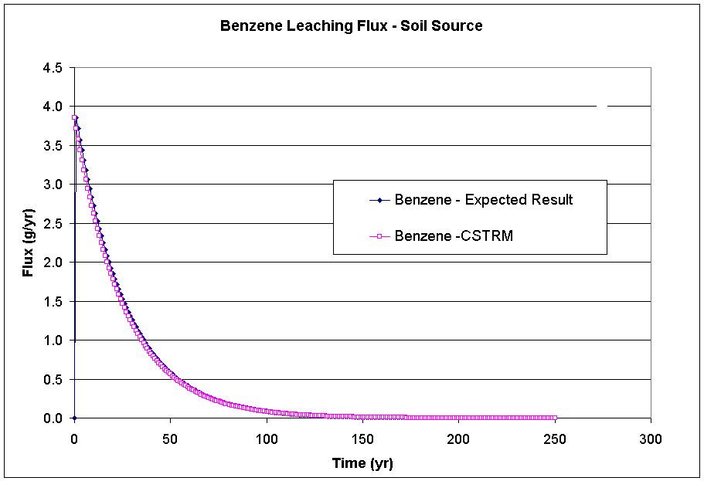
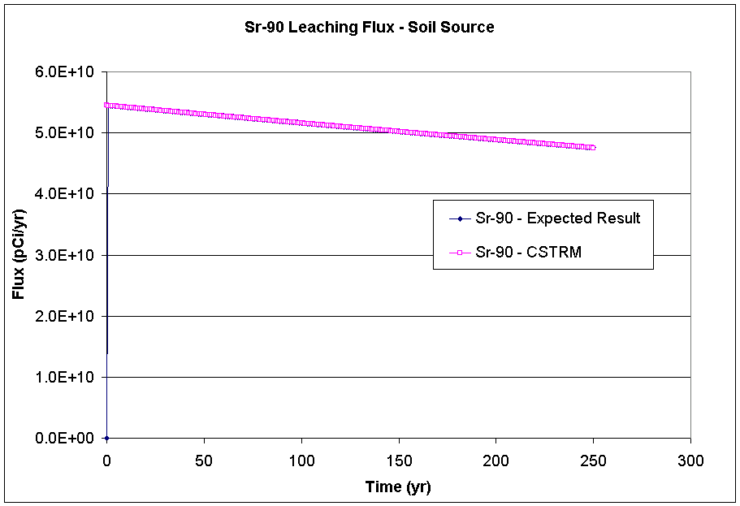

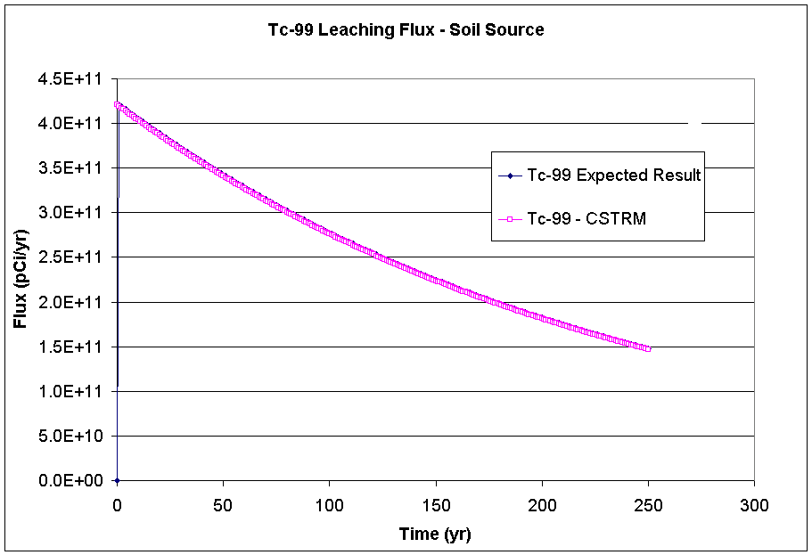

3.12b.2 Input Data

The default input data for this case is listed in Appendix B. Several changes were made to the default parameters listed. The parameter ‘overland runoff’ was changed from ‘Turn off pathway’ to ‘Known erosion rate’ and the parameter ‘STMAXTIME’ was changed to 250 years on the Options tab. The additional input data required are listed below.

The following table lists the input data required for both the Kd’s and Constituent Properties tabs.

Parameter | Value | Unit
STKD (Benzene) | 0.14 | ml/g
STKD (Sr-90) | 24.3 | ml/g
STKD (Tc-99) | 3.0 | ml/g
STKD (Yt-90) | 228.0 | ml/g
STSOL (Benzene) | 1750.0 | mg/L
STSOL (Sr-90) | 1.0E+06 | mg/L
STSOL (Tc-99) | 1.0E+06 | mg/L
STSOL (Yt-90) | 1.0E+06 | mg/L
STINVEN (Benzene) | 100.0 | g
STINVEN (Sr-90) | 100.0 | Ci
STINVEN (Tc-99) | 100.0 | Ci

The following table lists the input data required for the ‘Known Media Releases’ tab.

Parameter | Value | Unit
STWATR | 10 | cm/yr

The following table lists the input data required for the ‘Overland’ tab.

Parameter | Value | Unit
STOVLFLO | 4 | m^3/yr

3.12b.3 Expected Results

It is expected that the CSTRM will mass partition all contaminants into proper phases and partition each contaminant to the overland runoff loss route while maintaining mass balance. Hand calculations were performed to compute expected results. They can be seen in the results section in the graph that displays the expected and actual code computed results.

3.12b.4 Procedure

Instructions for running this case can be found in Appendix A. Save this case as scenario 2 on a GID file tcase12.gid. As noted above, use the default parameter values provided unless otherwise instructed. An additional difference is that the contaminant database ‘FRAMES Test 12 Chemical Database Selection’ will be used instead of the ‘FRAMES Default Chemical Database Selection’. This database has been modified such that the half-life for Sr-90 is very long in order to isolate the leaching loss route from the decay loss route. The additional input data required are listed in section 3.12b.2. Attach a WFF viewer to view the results.

3.12b.5 Results

The results of interest in this test case are the mass fluxes lost to overland runoff as calculated by the CSTRM. They can be found in the WFF file, which is located in the folder where the ‘tcase12b.gid’ file is located. The graph below shows the CSTRM computed values along with the expected results that were hand calculated.

Tcase12b_WFF.xls

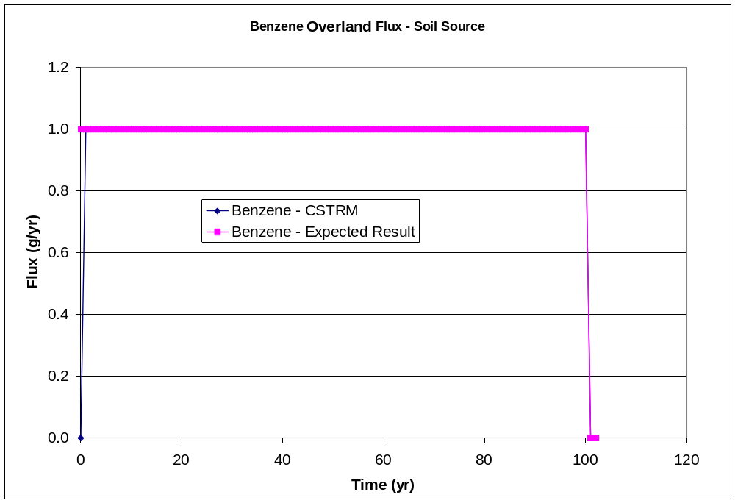
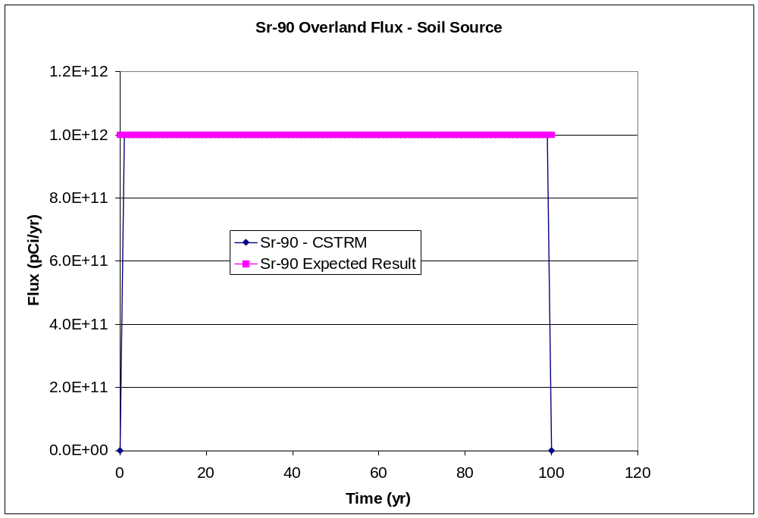
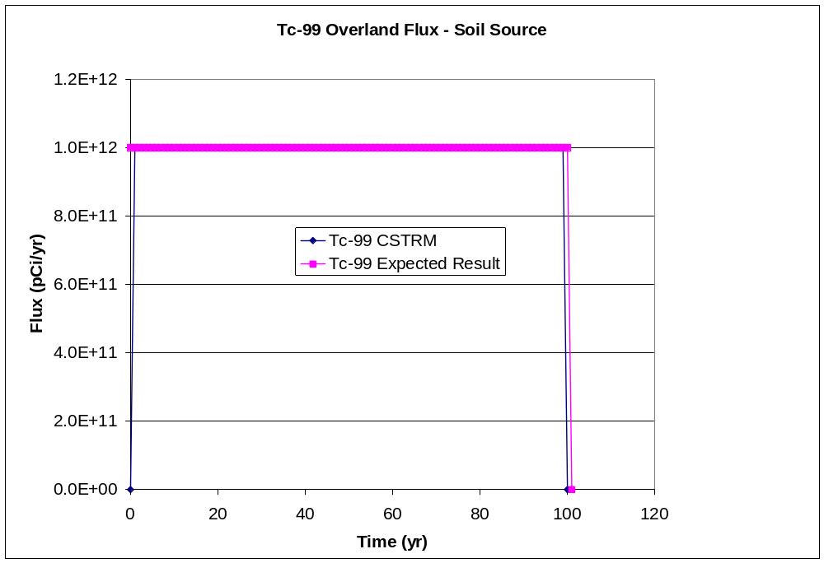

3.12c.2 Input Data

The default input data for this case is listed in Appendix B. Several changes were made to the default parameters listed. The parameter ‘suspension’ was changed from ‘Turn off pathway’ to ‘Known erosion rate’ and the parameter ‘STMAXTIME’ was changed to 250 years on the Options tab. The additional input data required are listed below.

The following table lists the input data required for both the Kd’s and Constituent Properties tabs.

Parameter | Value | Unit
STKD (Benzene) | 0.14 | ml/g
STKD (Sr-90) | 24.3 | ml/g
STKD (Tc-99) | 3.0 | ml/g
STKD (Yt-90) | 228.0 | ml/g
STSOL (Benzene) | 1750.0 | mg/L
STSOL (Sr-90) | 1.0E+06 | mg/L
STSOL (Tc-99) | 1.0E+06 | mg/L
STSOL (Yt-90) | 1.0E+06 | mg/L
STINVEN (Benzene) | 100.0 | g
STINVEN (Sr-90) | 100.0 | Ci
STINVEN (Tc-99) | 100.0 | Ci

The following table lists the input data required for the ‘Known Media Releases’ tab.

Parameter | Value | Unit
STWIND | 10 | cm/yr

3.12c.3 Expected Results

It is expected that the CSTRM will mass partition all contaminants into proper phases and partition each contaminant to the suspension loss route while maintaining mass balance.
Hand calculations were performed to compute expected results. They are listed in the following table.

Parameter | Value | Time (years)
Benzene Flux (g/yr) | 1.0 | 0
 | 1.0 | 100
Sr-90 Flux (pCi/yr) | 1.0E+12 | 0
 | 1.0E+12 | 100
Tc-99 Flux (pCi/yr) | 1.0E+12 | 0
 | 1.0E+12 | 100

3.12c.4 Procedure

Instructions for running this case can be found in Appendix A. Save this case as scenario 3 on the GID file tcase12.gid. As noted above, use the default parameter values provided unless otherwise instructed. An additional difference is that the contaminant database ‘FRAMES Test 12 Chemical Database Selection’ will be used instead of the ‘FRAMES Default Chemical Database Selection’. This database has been modified such that the half-life for Sr-90 is very long in order to isolate the leaching loss route from the decay loss route. The additional input data required are listed in section 3.12c.2. Attach an AFF viewer to view the results.

3.12c.5 Results

The results of interest in this test case are the mass fluxes lost to suspension as calculated by the CSTRM. They can be found in the AFF file, which is located in the folder where the ‘tcase12c.gid’ is located. The portion of the AFF that corresponds to this case is listed below. The important values are in bold and it can be seen that they match the expected values well.

Tcase12c.AFF

********************************************************************************
* File: c:\frames\tcase12c\tcase12c.aff
* Section: src2
* Date: 8/14/2003 11:22:39 AM
********************************************************************************

7
================================================================================
Source Term Release Module Version: Framework PoP January 1997
Run:
Site:
Run Performed:
Output Filename:
================================================================================
1
All
area
100
0,m2
0,m
0,m/s
20,Deg C
20,Deg C
2
Gas 1,0,fraction,0,g/cm^3
Particle 1,7.5,um,1.5,g/cm^3
3
Benzene,71432,yr,g/yr,4,0
0,0,0
2,0,1
100,0,1
102,0,0
STRONTIUM-90,SR90,yr,pCi/yr,4,1
0,0,0
2,0,9.999997338e+11
99,0,9.999765996e+11
101,0,0
YTTRIUM-90,Y90,yr,pCi/yr,5,STRONTIUM-90,SR90
0,0,0
5,0,1.005095813e+12
93,0,1.061062312e+12
99,0,1.243340997e+12
102,0,0
TECHNETIUM-99,TC99,yr,pCi/yr,4,0
0,0,0
2,0,9.999967846e+11
99,0,9.996810977e+11
101,0,0

3.12d.2 Input Data

The default input data for this case is listed in Appendix B. The purpose of this test case was to check that the radionuclide decay is working properly. Several changes were made to the default parameters listed. The parameter ‘leaching loss route’ was changed to ‘Known infiltration rate’, and ‘STMAXTIME’ was changed to 250 years on the Options tab. The additional input data required are listed below.

The following table lists the input data required for both the Kd’s and Constituent Properties tabs.

Parameter | Value | Unit
STKD (Benzene) | 0.14 | ml/g
STKD (Sr-90) | 24.3 | ml/g
STKD (Tc-99) | 3.0 | ml/g
STKD (Yt-90) | 228.0 | ml/g
STSOL (Benzene) | 1750.0 | mg/L
STSOL (Sr-90) | 1.0E+06 | mg/L
STSOL (Tc-99) | 1.0E+06 | mg/L
STSOL (Yt-90) | 1.0E+06 | mg/L
STINVEN (Benzene) | 100.0 | g
STINVEN (Sr-90) | 100.0 | Ci
STINVEN (Tc-99) | 100.0 | Ci

The following table lists the input data required for the ‘Known Media Releases’ tab.

Parameter | Value | Unit
STDARCY | 0 | cm/yr

3.12d.3 Expected Results

It is expected that the CSTRM will correctly calculate losses of mass due to radioactive decay for rads and compute no mass lost for non-rads. Hand calculations were performed to compute expected results. They can be seen in the results section in the graph that displays the expected and actual code computed results.

3.12d.4 Procedure

Instructions for running this case can be found in Appendix A. Save this case as scenario 4 on the GID file tcase12.gid. As noted above, use the default parameter values provided unless otherwise instructed. The additional input data required are listed in section 3.12d.2.

3.12d.5 Results

The results of interest in this test case are the remaining soil concentrations calculated by the CSTRM. They can be found in the .SCF file, which is located in the folder where the file ‘tcase12d.gid’ is located. The file will be called ‘tcase12d’ and will show no extension. The graph below shows the CSTRM computed values along with the expected results that were hand calculated.

Tcase12d_SCF.xls

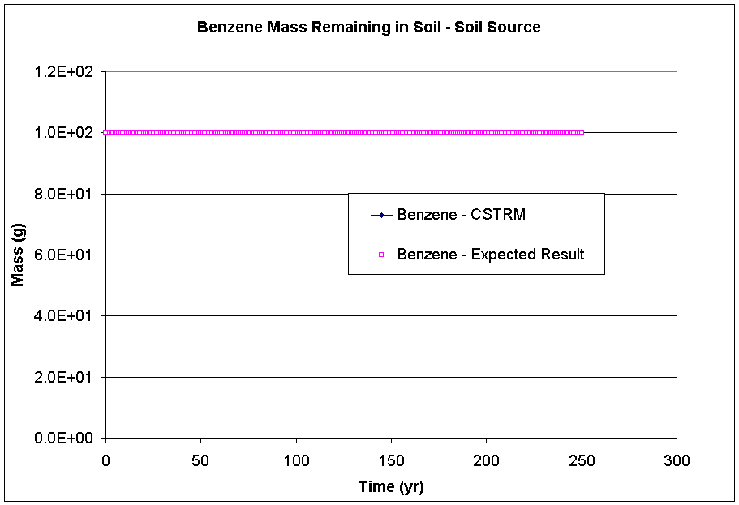
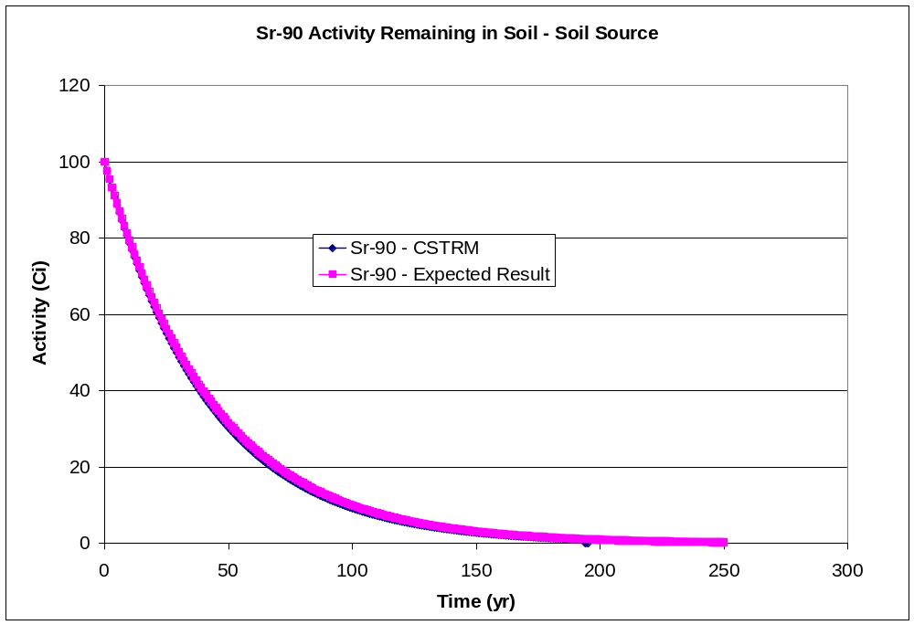
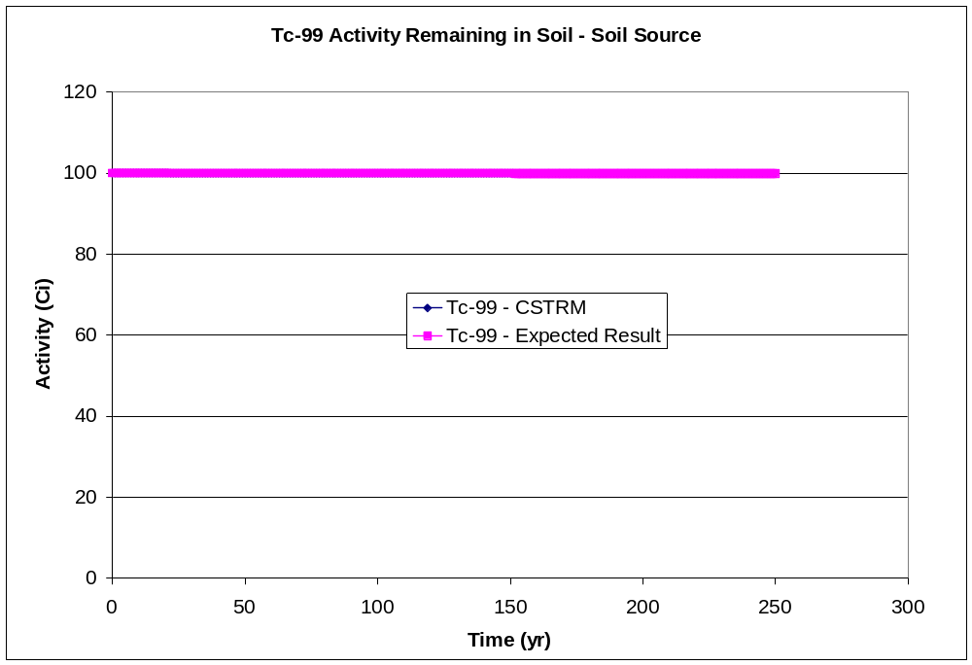

3.12e.2 Input Data

The default input data for this case is listed in Appendix B. Several changes were made to the default parameters listed. The parameters ‘leaching’, ‘overland runoff’, and ‘suspension’ were changed from ‘Turn off pathway’ to ‘Known infiltration rate’, ‘Known erosion rate’, and ‘Known erosion rate’ respectively on the Options tab. The parameter ‘STMAXTIME’ was changed to 250 years. The additional input data required are listed below.

The following table lists the input data required for both the Kd’s and Constituent Properties tabs.

Parameter | Value | Unit
STKD (Benzene) | 0.14 | ml/g
STKD (Sr-90) | 24.3 | ml/g
STKD (Tc-99) | 3.0 | ml/g
STKD (Yt-90) | 228.0 | ml/g
STSOL (Benzene) | 1750.0 | mg/L
STSOL (Sr-90) | 1.0E+06 | mg/L
STSOL (Tc-99) | 1.0E+06 | mg/L
STSOL (Yt-90) | 1.0E+06 | mg/L
STINVEN (Benzene) | 100.0 | g
STINVEN (Sr-90) | 100.0 | Ci
STINVEN (Tc-99) | 100.0 | Ci

The following table lists the input data required for the ‘Known Media Releases’ tab.

Parameter | Value | Unit
STDARCY | 20 | cm/yr
STWATR | 10 | cm/yr
STWIND | 10 | cm/yr

The following table lists the input data required for the ‘Overland’ tab.

Parameter | Value | Unit
STOVLFLO | 4 | m^3/yr

3.12e.3 Expected Results

It is expected that the CSTRM will mass partition all contaminants into proper phases and partition each contaminant to the each loss route while maintaining mass balance. Hand calculations were performed but are not listed here. They can be seen in the results section graphed with the actual CSTRM results.

3.12e.4 Procedure

Instructions for running this case can be found in Appendix A. As noted above, use the default parameter values provided unless otherwise instructed. The additional input data required are listed in section 3.12c.2.

3.12e.5 Results

The results of interest in this test case are the remaining soil concentrations calculated by the CSTRM. They can be found in the SCF file that will be located in the folder where the file ‘tcase12e.gid’ is located. The file will be called ‘tcase12e’ and will show no extension. The results are presented on graphs below along with the expected results.

Tcase12e_SCF.xls

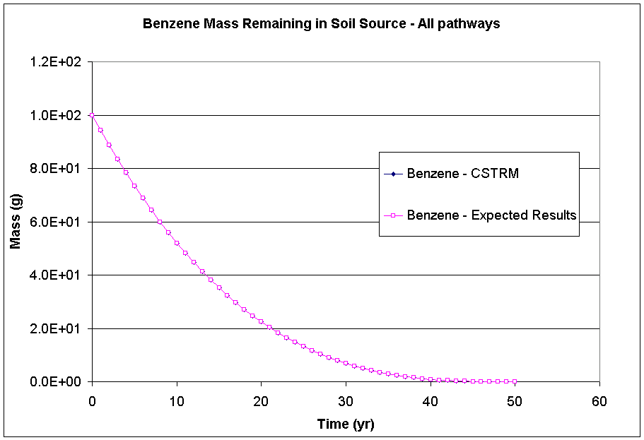
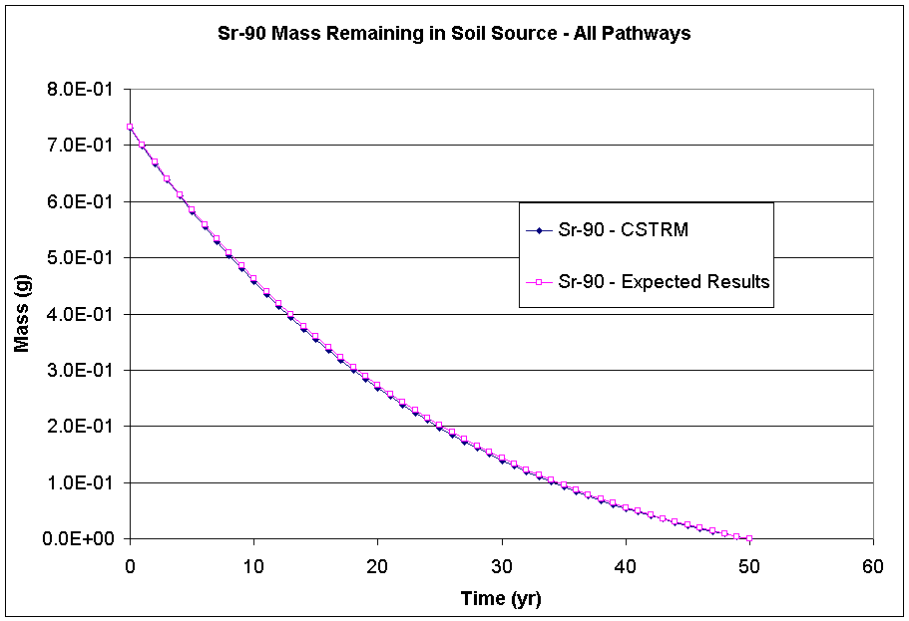
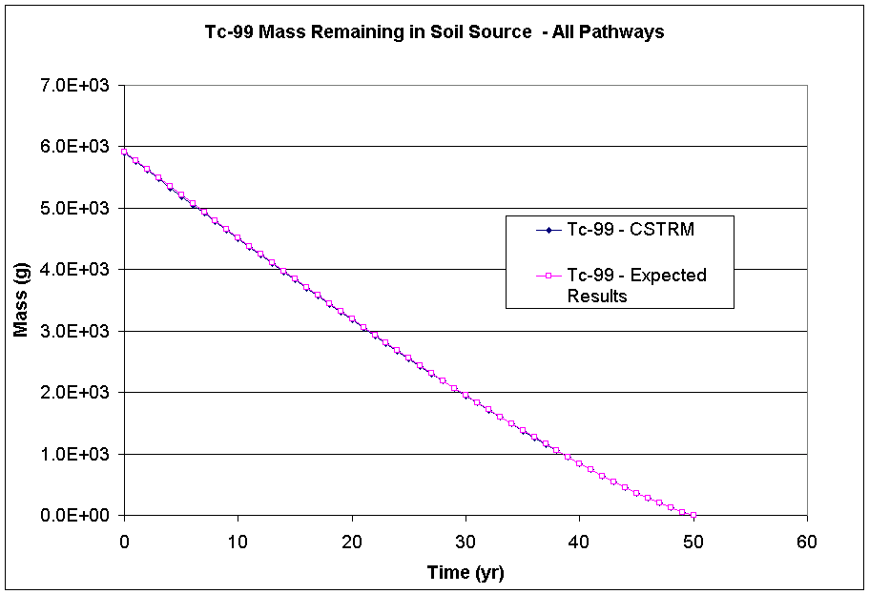

3.13 Tcase13

3.13.1 Description and Rationale

This case verifies that when a constituent is present in the source as a parent and is being generated as a decay product of another constituent, the CSTRM maintains mass balance and correctly partitions the constituents to a specified pathway. One scenario was set up in this test case. The source media is surface soils and leaching was the only transport pathway. The constituents Sr-90 and Yt-90 were selected for this case. Yt-90 is the lone decay product of Strontium-90.

3.13.2 Input Data

The default input data for this case is listed in Appendix B. Several changes were made to the default parameters listed. The parameter ‘leaching loss route’ was changed to ‘Known infiltration rate’ and ‘STMAXTIME’ was changed to 10 years on the Options tab. Additional input data required are listed below.

The following table lists the input data required for both the Kd’s and Constituent Properties tabs.

Parameter | Value | Unit
STKD (Sr-90) | 24.3 | ml/g
STKD (Yt-90) | 228.0 | ml/g
STSOL (Sr-90) | 1.0E+06 | mg/L
STSOL (Yt-90) | 1.0E+06 | mg/L
STINVEN (Sr-90) | 100.0 | Ci
STINVEN (Tc-99) | 100.0 | Ci

The following table lists the input data required for the ‘Known Media Releases’ tab.

Parameter | Value | Unit
STDARCY | 20 | cm/yr

3.13.3 Expected Results

It is expected that the CSTRM will properly maintain mass balance for Sr-90 and Yt-90 even though Yt-90 is a parent and a decay product that is being generated. The CSTRM should keep the Yt-90 that started as a parent and the Yt-90 that is being generated as Sr-90 decays separate in terms of mass fluxes out of the source and source concentrations.

3.13.4 Procedure

Instructions for running this case can be found in Appendix A. As noted above, use the default parameter values provided unless otherwise instructed. The additional input data required are listed in section 3.13.2.

3.13.5 Results

The result of interest in this test case is to check that CSTRM kept the Yt-90 that started as a parent and the Yt-90 that was generated from Sr-90 decay separate in both the mass flux lost to infiltration and the mass remaining in the soil source. They can be found in the WFF and SDL files that are located in the working FRAMES directory and are listed below. As can be seen, the CSTRM accounts for the mass flux of the parent and decay product Yt-90 separately. A check was also made in the SDL file to ensure that separate sections existed for the parent and decay product Yt-90.

Tcase13.WFF

"src2",0000000081
7,
"================================================================================",
" Source Term Release Module Version: Framework PoP January 1997 ",
" Run:","D:\FUI\~glyph",
" Site:","src2",
" Run Performed:","8/2/1999","9:28:57",
" Output Filename:","D:\FUI\~glyph.wff",
"================================================================================",
1,
"src2","Vadose",10,"m",10,"m",0,"m",0.200000003,"m/yr",2,
"yr","m^3/yr",2,
0,20,
30,20,
"STRONTIUM-90","SR90","yr","pCi/yr", 31,1,1,
0,0,
1,5.449592013e+10,
2,5.318076006e+10,
3,5.1897344e+10,
4,5.064489779e+10,
5,4.942267597e+10,
6,4.822995354e+10,
7,4.70660096e+10,
8,4.593016013e+10,
9,4.482172518e+10,
10,4.374003302e+10,
11,4.268444877e+10,
12,4.165434163e+10,
13,4.064909312e+10,
14,3.966810112e+10,
15,3.87107799e+10,
16,3.777657242e+10,
17,3.686490522e+10,
18,3.597524173e+10,
19,3.510704538e+10,
20,3.425980006e+10,
21,3.343300403e+10,
22,3.262616166e+10,
23,3.183878963e+10,
24,3.107042099e+10,
25,3.03205929e+10,
26,2.958886298e+10,
27,2.887479091e+10,
28,2.817794867e+10,
29,2.74979287e+10,
30,2.683431731e+10,
"YTTRIUM-90","Y90","yr","pCi/yr", 31,1,"STRONTIUM-90","SR90",
0,0,
1,0,
2,5772877824,
3,5633559552,
4,5497603072,
5,5364930048,
6,5235457536,
7,5109109248,
8,4985810944,
9,4865486848,
10,4748067328,
11,4633481728,
12,4521661440,
13,4412539904,
14,4306051072,
15,4202132992,
16,4100722432,
17,4001758976,
18,3905183744,
19,3810939392,
20,3718970112,
21,3629219584,
22,3541635072,
23,3456164352,
24,3372755968,
25,3291360768,
26,3211929856,
27,3134415872,
28,3058772480,
29,2984954624,
30,2912918784,
"YTTRIUM-90","Y90","yr","pCi/yr", 3,1,0,
0,0,
1,62320992,
2,0,

3.14 Tcase14

3.14.1 Description and Rationale

This case verifies that the CSTRM will allow the user to enter 1) user-defined constituent mass flux rates leaving the source and 2) time-varying contaminant sources and sinks. One scenario was set up in this test case. The constituents chosen were chromium VI (Cr VI) and lead. A time-varying lead source and a known Cr VI sink will be entered. The source media is surface soils and leaching and volatilization were the only transport pathways. A known leach loss rate was used to be able to predict the expected results easily. A computed volatilization rate was used because the CSTRM will not run unless at least one of the loss routes is computed. The volatilization loss route will not have an affect on the leaching loss route because neither of the two constituents chosen volatilizes.

3.14.2 Input Data

The default input data for this case is listed in Appendix B. Several changes were made to the default parameters listed. The parameter ‘leaching’ was changed to ‘Known Constituent Flux’, ‘volatilization loss route’ was changed to ‘Compute Pathway’, ‘source/sink’ was changed to ‘Known constituent flux’ and ‘STMAXTIME’ was changed to 40 years on the Options tab. Additional input data required are listed below.

The following table lists the input data required for both the Kd’s and Constituent Properties tabs.

Parameter | Value | Unit
STKD (Cr VI) | 16.8 | ml/g
STKD (lead) | 234 | ml/g
STSOL (Cr VI) | 1.0E+06 | mg/L
STSOL (lead) | 1.0E+06 | mg/L
STINVEN (Cr VI) | 20.0 | g
STINVEN (lead) | 20.0 | g
STVOLRAT (Cr VI) | 1.0 | fraction
STVOLRAT (lead) | 1.0 | fraction

The following table lists the input data required for the ‘Known Media Releases’ tab.

Parameter | Value | Unit
STDARCY | 10 | cm/yr

The following table lists the input data required for the ‘Known Contaminant Flux’ tab.

Parameter | # of Measurements | Value | Year of Measurement
STLEACH (Cr VI) | 2 | 1.0 | 0
 |  | 1.0 | 40
STLEACH (lead) | 2 | 1.0 | 0
 |  | 1.0 | 40
STSOURCE (Cr VI) | 4 | -2.0 | 1
 |  | -2.0 | 5
 |  | 0.0 | 5.1
 |  | 0.0 | 40
STSOURCE (lead) | 4 | 1.0 | 1
 |  | 1.0 | 10
 |  | 0.0 | 10.1
 |  | 0.0 | 40

3.14.3 Expected Results

It is expected that the CSTRM will properly maintain mass balance for Cr VI and lead while incorporating in the time-varying source and sinks. Without the source or sink, both constituents would have a 1 g or Ci/ year leach flux for 20 years. However, with the source and sink that are entered, the Cr VI flux should change to 1 g/yr leach flux for 10 years and the lead flux should be 1 Ci/yr for 30 years.

3.14.4 Procedure

Instructions for running this case can be found in Appendix A. As noted above, use the default parameter values provided unless otherwise instructed. The additional input data required are listed in section 3.15.2. Attach a WFF viewer to view the results.

3.14.5 Results

The results of interest in this test case are the mass flux lost to infiltration calculated by the CSTRM. They can be found in the WFF file that is located in the working FRAMES directory and is listed below. The values calculated can be compared with the expected result listed above.

Tcase14.WFF

"src2",0000000061
7,
"================================================================================",
" Source Term Release Module Version: Framework PoP January 1997 ",
" Run:","D:\FUI\~glyph",
" Site:","src2",
" Run Performed:","3/30/1999","11:33:32",
" Output Filename:","D:\FUI\~glyph.wff",
"================================================================================",
1,
"src2","Vadose",10,"m",10,"m",0,"m",0.1000000015,"m/yr",2,
"yr","m^3/yr",2,
0,10,
40,10,
"Chromium VI","7440473","yr","g/yr", 13,1,0,
0,0,
1,1,
2,1,
3,1,
4,1,
5,1,
6,1,
7,1,
8,1,
9,1,
10,1,
11,0,
12,0,
"Lead","7439921","yr","g/yr", 33,1,0,
0,0,
1,1,
2,1,
3,1,
4,1,
5,1,
6,1,
7,1,
8,1,
9,1,
10,1,
11,1,
12,1,
13,1,
14,1,
15,1,
16,1,
17,1,
18,1,
19,1,
20,1,
21,1,
22,1,
23,1,
24,1,
25,1,
26,1,
27,1,
28,1,
29,1,
30,1,
31,0,
32,0,

3.15 Tcase15

3.15.1 Description and Rationale

This case verifies that the CSTRM will truncate a known contaminant flux release when the inventory entered runs out. The constituent benzene was used. A known benzene flux was entered, but the inventory set such that it should run out before the specified known flux release ends. The source media was surface soils and leaching was the only transport pathway.

3.15.2 Input Data

The default input data for this case is listed in Appendix B. Several changes were made to the default parameters listed. The parameter ‘leaching’ was changed from ‘Turn off pathway’ to ‘Known contaminant flux’ and the parameter ‘STMAXTIME’ was changed to 20 years on the Options tab. Additional input data required are listed below.

The following table lists the input data required for both the Kd’s and Constituent Properties tabs.

Parameter | Value | Unit
STKD | 0.14 | ml/g
STSOL | 1750.0 | mg/L
STINVEN | 10.0 | g

The following table lists the input data required for the ‘Known Media Releases’ tab.

Parameter | Value | Unit
STDARCY | 20 | cm/yr

The following table lists the input data required for the ‘Known Contaminant Flux’ tab.

Parameter | # of Measurements | Value | Year of Measurement
STLEACH (Sr-90) | 2 | 1.0 | 0
 |  | 1.0 | 20

3.15.3 Expected Results

It is expected that the CSTRM will stop releasing benzene after the tenth year because the inventory runs even though the known benzene flux specifies that it will last for 20 years.

3.15.4 Procedure

Instructions for running this case can be found in Appendix A. Save this case as tcase15.gid. As noted above, use the default parameter values provided unless otherwise instructed. The additional input data required are listed in section 3.15.2. Attach a WFF viewer to view the results.

3.15.5 Results

The results of interest in this test case are the mass flux lost to infiltration calculated by the CSTRM. The flux can be found in the WFF file listed below. The WFF file can be found in the working FRAMES directory. The results are as expected. The benzene flux stopped after ten years due to a inventory constraint even though the known benzene flux specified that the flux would last for 20 years.

Tcase15.WFF

"src2",0000000027
7,
"=============================================================================",
" Source Term Release Module Version: Framework PoP January 1997 ",
" Run:","D:\FUI\~glyph",
" Site:","src2",
" Run Performed:","3/22/1999","14:53:17",
" Output Filename:","D:\FUI\~glyph.wff",
"=============================================================================",
1,
"src2","Vadose",10,"m",10,"m",0,"m",0.200000003,"m/yr",1,
"yr","m^3/yr",2,
0,20,
20,20,
"Benzene","71432","yr","g/yr", 13,1,0,
0,0,
1,1,
2,1,
3,1,
4,1,
5,1,
6,1,
7,1,
8,1,
9,1,
10,1,
11,0,
12,0,

3.16 Tcase16

3.16.1 Description and Rationale

This case verifies that the CSTRM will allow the user to enter in contaminant mass as a concentration and correctly computes the contaminant inventory based on the type of concentration entered. The constituent benzene was used and its initial mass was entered in as a concentration. Three scenarios were run to account for the three types of source media. In the first scenario, 3.16a, the source medium was surface soils. In the second scenario, 3.16b, the source medium was surface water. In the third scenario, 3.16c, the source medium was an aquifer. Leaching was the only transport pathway. This test case will also verify that the CSTRM will provide estimated Kd values for constituents when requested.

3.16a.2 Input Data

The default input data for this case is listed in Appendix B. One change was made to the default parameters listed. The parameter ‘leaching’ was changed from ‘Turn off pathway’ to ‘Known contaminant flux’. Additional input data required are listed below.

The following table lists the input data required for the Soil Triangle window

Parameter | Value | Unit
KD-SAND | 83 | %
KD-SILT | 11 | %
KD-CLAY | 6 | %
KD-OMC | 0 | %
KD-IRON | 0 | %
KD-PH | 7 | unitless

The following table lists the input data required for both the Kd’s and Constituent Properties tabs.

Parameter | Value | Unit
STSOL (benzene) | 1750.0 | mg/L
STGHALF (benzene) | 0 | days

The following table lists the input data required for the Contaminant Inventory Worksheet.

Parameter | Value | Unit
Mass contaminant / Mass soil Wet | 5.71429E-08 | g/g
Mass contaminant / Mass soil Dry | 6.66667E-08 | g/g
Mass contaminant / Volume soil | 1.00E-07 | g/cm^3

The following table lists the input data required for the ‘Known Media Releases’ tab.

Parameter | Value | Unit
STDARCY | 20 | cm/yr

The following table lists the input data required for the ‘Known Contaminant Flux’ tab.

Parameter | # of Measurements | Value (g/yr) | Year of Measurement
STLEACH (benzene) | 2 | 1.0 | 0
 |  | 1.0 | 10

3.16a.3 Expected Results

It is expected that the CSTRM will correctly compute an inventory of 100 g for each of the three types of concentrations entered. It is also expected that the CSTRM will provide an estimated Kd when requested.

3.16a.4 Procedure

General instructions for running this case can be found in Appendix A. This test case will require several additional steps, which will be described below. As noted above, use the default parameter values provided unless otherwise instructed. The additional input data required are listed in section 3.16.2.

To enter the data required by the CSTRM to compute an estimated Kd, click on the Kd’s tab. On the Kd’s tab there is an ‘Estimate Kd’s’ button. Click on this button. The Soil Triangle window will appear. Fill in the data from the table in section 3.16a.2. When finished, click the ‘ok’ button. The estimated Kd value computed by the CSTRM will appear to the left of the ‘Count’ column. Enter this value in the ‘Value’ column.

To enter the concentration data, click on the Contaminant Properties tab. On the Contaminant Properties tab, click on the green cell with the word ‘Worksheet’ in it. An inventory worksheet window will appear. In the section titled ‘Concentration’ the first drop down box contains the choices for the concentration type to be entered. Pick ‘Mass contaminant/Mass soil Wet’, enter the corresponding concentration value listed in section 3.16a.2, and check the value listed in the ‘Inventory’ section box. Then use the drop down box to choose ‘Mass contaminant/Mass soil Dry’, enter the corresponding concentration value listed in section 3.16a.2, and check the value listed in the ‘Inventory’ section box. Finally, use the drop down box to choose ‘Mass contaminant/Volume soil’, enter the corresponding concentration value listed in section 3.16a.2, and check the value listed in the ‘Inventory’ section box.

3.16a.5 Results

The CSTRM correctly computed a benzene inventory of 100 g for each of the three types of concentrations entered. The CSTRM also provided an estimated Kd value based on input data when requested.

3.16b.2 Input Data

The default input data for this case is listed in Appendix B. Several changes were made to the default parameters listed. The parameter ‘STINF_OP’ was changed from ‘Turn off pathway’ to ‘Known infiltration rate’ and the parameter ‘STMEDIA’ was changed from ‘Soil/Vadose’ to ‘Surface Water’. Additional input data required are listed below.

The following table lists the input data required for the Waste Zone tab

Parameter | Value | Unit
STTHICK | 1000 | cm
STLENGTH | 1000 | cm
STWIDTH | 1000 | cm
STZBULKD | 1.5 | g/cm^3
STSSOL | 0 | fraction
STAVTEMP | 20 | C
STWINDHT | 10 | m

The following table lists the input data required for the Soil Triangle window

Parameter | Value | Unit
KD-SAND | 83 | %
KD-SILT | 11 | %
KD-CLAY | 6 | %
KD-OMC | 0 | %
KD-IRON | 0 | %
KD-PH | 7 | unitless

The following table lists the input data required for both the Kd’s and Constituent Properties tabs.

Parameter | Value | Unit
STSOL (benzene) | 1750.0 | mg/L
STGHALF (benzene) | 0 | days

The following table lists the input data required for the Contaminant Inventory Worksheet.

Parameter | Value | Unit
Mass aqueous contaminant / Volume water | 1.0E-07 | g/mL

The following table lists the input data required for the ‘Known Media Releases’ tab.

Parameter | Value | Unit
STDARCY | 10 | cm/yr

3.16b.3 Expected Results

It is expected that the CSTRM will correctly compute an inventory of 100 g for the concentration entered. It is also expected that the CSTRM will provide an estimated Kd when requested.

3.16b.4 Procedure

General instructions for running this case can be found in Appendix A. This test case will require several additional steps, which will be described below. As noted above, use the default parameter values provided unless otherwise instructed. The additional input data required are listed in section 3.16.2.

To enter the data required by the CSTRM to compute an estimated Kd, click on the Kd’s tab. On the Kd’s tab there is an ‘Estimate Kd’s’ button. Click on this button. The Soil Triangle window will appear. Fill in the data from the table in section 3.16b.2. When finished, click the ‘ok’ button. The estimated Kd value computed by the CSTRM will appear to the left of the ‘Count’ column. Enter this value in the ‘Value’ column.

To enter the concentration data, click on the Contaminant Properties tab. On the Contaminant Properties tab, click on the green cell with the word ‘Worksheet’ in it. An inventory worksheet window will appear. In the section titled ‘Concentration’ the first drop down box contains the choices for the concentration type to be entered. When the source media is surface water, the only choice is ‘Mass aqueous contaminant/Volume water’. Enter the concentration value listed in section 3.16b.2, and check the value listed in the ‘Inventory’ section box.

3.16b.5 Results

The CSTRM correctly computed a benzene inventory of 100 g for the concentration entered. The CSTRM also provided an estimated Kd value based on input data when requested.

3.16c.2 Input Data

The default input data for this case is listed in Appendix B. Several changes were made to the default parameters listed. The parameter ‘STINF_OP’ was changed from ‘Turn off pathway’ to ‘Known darcy velocity’ and the parameter ‘STMEDIA’ was changed from ‘Soil/Vadose’ to ‘Aquifer’. Additional input data required are listed below.

The following table lists the input data required for the Waste Zone tab

Parameter | Value | Unit
STCLEAN | 0 | cm
STTHICK | 1000 | cm
STLENGTH | 1000 | cm
STWIDTH | 1000 | cm
STZBULKD | 1.5 | g/cm^3
STTOTPOR | 0.434 | fraction
STEFFPOR | 0.25 | fraction
STAVTEMP | 20 | C
STWINDHT | 10 | m

The following table lists the input data required for the Soil Triangle window

Parameter | Value | Unit
KD-SAND | 83 | %
KD-SILT | 11 | %
KD-CLAY | 6 | %
KD-OMC | 0 | %
KD-IRON | 0 | %
KD-PH | 7 | unitless

The following table lists the input data required for both the Kd’s and Constituent Properties tabs.

Parameter | Value | Unit
STKD | 0.14 | ml/g
STSOL | 1750.0 | mg/L
STINVEN | 10.0 | g
STGHALF (benzene) | 0 | days

The following table lists the input data required for the Contaminant Inventory Worksheet.

Parameter | Value | Unit
Mass aqueous contaminant / Volume water | 1.5544e-07 | g/mL

The following table lists the input data required for the ‘Known Media Releases’ tab.

Parameter | Value | Unit
STDARCY | 10 | cm/yr

3.16c.3 Expected Results

It is expected that the CSTRM will correctly compute an inventory of 100 g for the concentration entered. It is also expected that the CSTRM will provide an estimated Kd when requested.

3.16c.4 Procedure

General instructions for running this case can be found in Appendix A. This test case will require several additional steps, which will be described below. As noted above, use the default parameter values provided unless otherwise instructed. The additional input data required are listed in section 3.16c.2.

To enter the data required by the CSTRM to compute an estimated Kd, click on the Kd’s tab. On the Kd’s tab there is an ‘Estimate Kd’s’ button. Click on this button. The Soil Triangle window will appear. Fill in the data from the table in section 3.16c.2. When finished, click the ‘ok’ button. The estimated Kd value computed by the CSTRM will appear to the left of the ‘Count’ column. Enter this value in the ‘Value’ column.

To enter the concentration data, click on the Contaminant Properties tab. On the Contaminant Properties tab, click on the green cell with the word ‘Worksheet’ in it. An inventory worksheet window will appear. In the section titled ‘Concentration’ the first drop down box contains the choices for the concentration type to be entered. When the source media is an aquifer, the only choice is ‘Mass aqueous contaminant/Volume water’. Enter the concentration value listed in section 3.16c.2, and check the value listed in the ‘Inventory’ section box.

3.16c.5 Results

The CSTRM correctly computed a benzene inventory of 100 g for the concentration entered. The CSTRM also provided an estimated Kd value based on input data when requested.

3.17 Tcase17

3.17.1 Description and Rationale

This case verifies that when the source media is an aquifer the CSTRM correctly executes phase distribution calculations and partitions the contaminants to all pathways while maintaining mass balance. Two scenarios were set up in this test case. The first scenario, 3.17a, was run with leaching and decay. The second scenario, 3.17b, was run with decay only. The constituents Benzene, Tc-99, and Sr-90 were selected for this case.

3.17a.2 Input Data

The default input data for this case is listed in Appendix B. Several changes were made to the default parameters listed. The parameter ‘STMEDIA’ was changed from ‘surface soil’ to ‘aquifer’, the parameter ‘leaching’ was changed to ‘Known darcy velocity’, the parameter ‘STMAXTIME’ was changed to 250 years on the Options tab. The additional input data required are listed below.

The following table lists the input data required for both the Kd’s and Constituent Properties tabs.

Parameter | Value | Unit
STKD (Benzene) | 0.14 | ml/g
STKD (Sr-90) | 24.3 | ml/g
STKD (Tc-99) | 3.0 | ml/g
STKD (Yt-90) | 228.0 | ml/g
STSOL (Benzene) | 1750.0 | mg/L
STSOL (Sr-90) | 1.0E+06 | mg/L
STSOL (Tc-99) | 1.0E+06 | mg/L
STSOL (Yt-90) | 1.0E+06 | mg/L
STINVEN (Benzene) | 100.0 | g
STINVEN (Sr-90) | 100.0 | Ci
STINVEN (Tc-99) | 100.0 | Ci

The following table lists the input data required for the ‘Known Media Releases’ tab.

Parameter | Value | Unit
STDARCY | 20 | cm/yr

3.17a.3 Expected Results

It is expected that the CSTRM will mass partition all contaminants into proper phases and partition each contaminant to the leaching loss route while maintaining mass balance. Hand calculations were performed based on the formulations. They are not posted here but can be seen in the results section graphed with the actual code results.

3.17a.4 Procedure

Instructions for running this case can be found in Appendix A. As noted above, use the default parameter values provided unless otherwise instructed. The additional input data required are listed in section 3.17a.2. A WFF viewer can be attached to view the results.

3.17a.5 Results

The results of interest in this test case are the mass flux lost to infiltration calculated by the CSTRM. They can be found in the WFF file which is located in the working FRAMES directory. The results are graphed along with the expected results and are listed below.

Tcase17a.WFF.xls

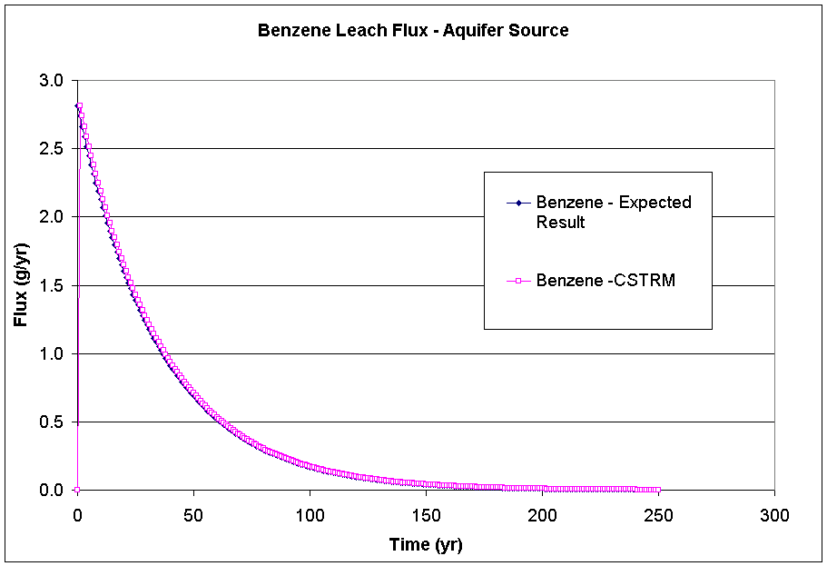
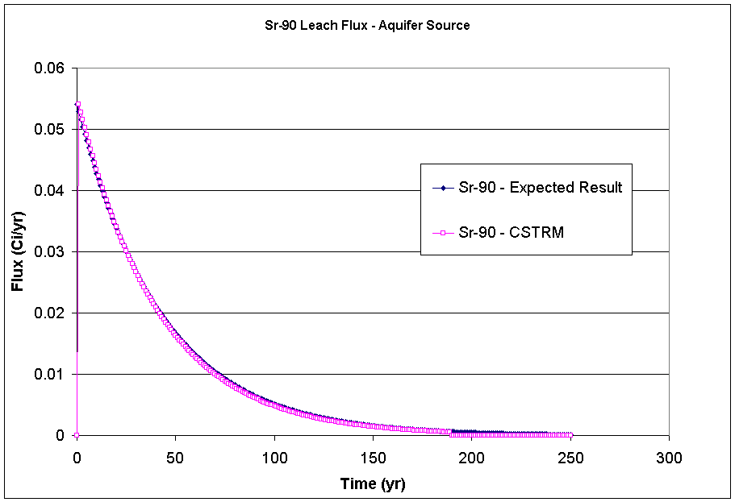
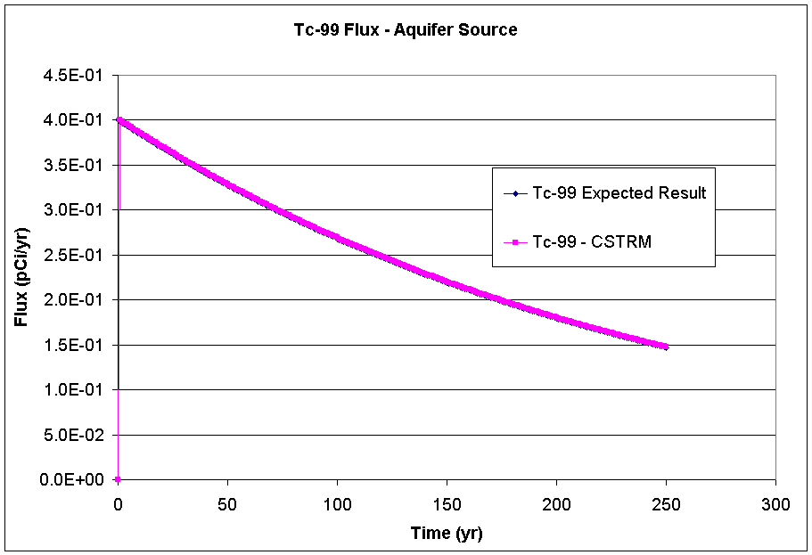

3.17b.2 Input Data

The default input data for this case is listed in Appendix B. Several changes were made to the default parameters listed. The parameter ‘STMEDIA’ was changed from ‘surface soil’ to ‘aquifer’, the parameter ‘leaching’ was changed from ‘Turn off pathway’ to ‘Known darcy velocity’, and the parameter ‘STMAXTIME’ was changed to 250 years on the Options tab. The additional input data required are listed below.

The following table lists the input data required for both the Kd’s and Constituent Properties tabs.

Parameter | Value | Unit
STKD (Benzene) | 0.14 | ml/g
STKD (Sr-90) | 24.3 | ml/g
STKD (Tc-99) | 3.0 | ml/g
STKD (Yt-90) | 228.0 | ml/g
STSOL (Benzene) | 1750.0 | mg/L
STSOL (Sr-90) | 1.0E+06 | mg/L
STSOL (Tc-99) | 1.0E+06 | mg/L
STSOL (Yt-90) | 1.0E+06 | mg/L
STINVEN (Benzene) | 100.0 | g
STINVEN (Sr-90) | 100.0 | Ci
STINVEN (Tc-99) | 100.0 | Ci

The following table lists the input data required for the ‘Known Media Releases’ tab.

Parameter | Value | Unit
STDARCY | 0 | cm/yr

3.17b.3 Expected Results

It is expected that the CSTRM will correctly calculate losses of mass due to radioactive decay for Sr-90 and Tc-99 and compute no mass lost for Benzene. Hand calculations were performed and can be seen in the results section graphed with the actual CSTRM results.

3.17b.4 Procedure

Instructions for running this case can be found in Appendix A. As noted above, use the default parameter values provided unless otherwise instructed. The additional input data required are listed in section 3.17b.2.

3.17b.5 Results

The result of interest in this test case is the remaining soil concentrations calculated by the CSTRM. They can be found in the SDL file that will be located in the working FRAMES directory. The results from this file are graphed along with the expected results and presented below.

Tcase17b_SDL.xls

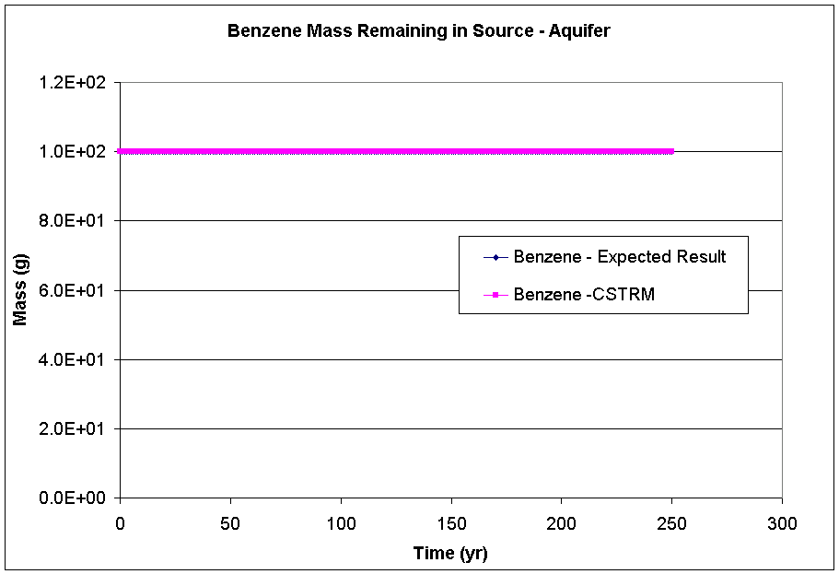

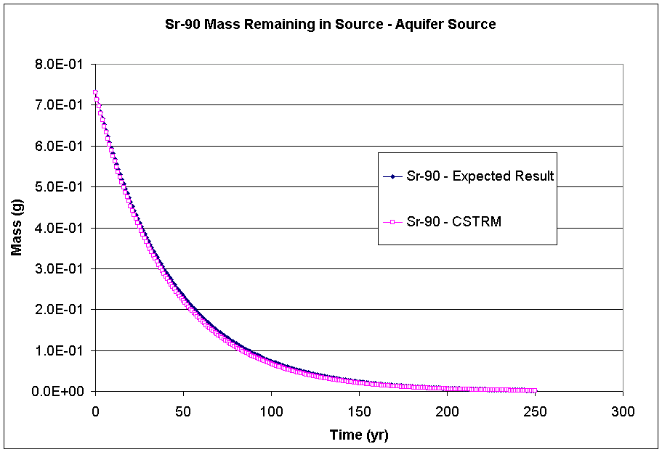

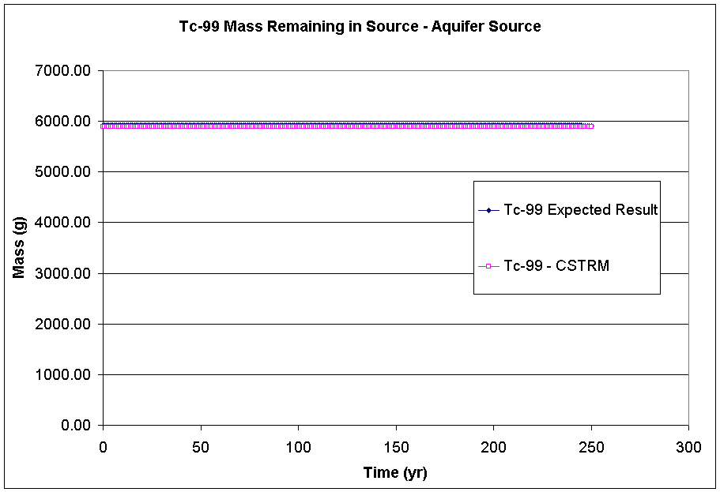

3.18 Tcase18

3.18.1 Description and Rationale

This case verifies that when the source media is surface water the CSTRM correctly executes phase distribution calculations and partitions the contaminants to all pathways while maintaining mass balance. Five scenarios were set up in this test case. The first scenario, 3.18a, was run with leaching and decay only. The second scenario, 3.18b, was run with overland runoff and decay only. The third scenario, 3.18c, was run with volatilization and decay only. The fourth scenario, 3.18d, was run with decay only. The fifth scenario, 3.18e, was run with all pathways turned on. The constituents benzene, Tc-99, and Sr-90 were selected for this case.

3.18a.2 Input Data

The default input data for this case is listed in Appendix B. Several changes were made to the default parameters listed. The parameter ‘source term media’ was changed to ‘surface water’, the parameter ‘leaching’ was changed to ‘Known infiltration rate’, and the parameter ‘STMAXTIME’ was changed to 250 years on the Options tab. Additionally, because the source media is not surface soil anymore, different parameters are required. The additional input data required are listed below.

The following table lists the input data required for the Release Site tab.

Parameter | Value | Unit
STTHICK | 1000 | cm
STLENGTH | 1000 | cm
STWIDTH | 1000 | cm
STZBULKD | 2.65 | g/cm^3
STSSOL | 0.1 | g/cm^3
STAVTEMP | 20 | C
STWINDHT | 7 | m

The following table lists the input data required for both the Kd’s and Constituent Properties tabs.

Parameter | Value | Unit
STKD (Benzene) | 0.14 | ml/g
STKD (Sr-90) | 24.3 | ml/g
STKD (Tc-99) | 3.0 | ml/g
STKD (Yt-90) | 228.0 | ml/g
STSOL (Benzene) | 1750.0 | mg/L
STSOL (Sr-90) | 1.0E+06 | mg/L
STSOL (Tc-99) | 1.0E+06 | mg/L
STSOL (Yt-90) | 1.0E+06 | mg/L
STINVEN (Benzene) | 100.0 | g
STINVEN (Sr-90) | 100.0 | Ci
STINVEN (Tc-99) | 100.0 | Ci

The following table lists the input data required for the ‘Known Media Releases’ tab.

Parameter | Value | Unit
STDARCY | 20 | cm/yr

3.18a.3 Expected Results

It is expected that the CSTRM will mass partition all contaminants into proper phases and partition each contaminant to the leaching loss route while maintaining mass balance. Hand calculations were performed but are not listed here. They can be seen graphed along with the actual CSTRM results in the results section.

3.18a.4 Procedure

Instructions for running this case can be found in Appendix A. As noted above, use the default parameter values provided unless otherwise instructed. An additional difference is that the contaminant database ‘FRAMES Test 12 Chemical Database Selection’ will be used instead of the ‘FRAMES Default Chemical Database Selection’. This database has been modified such that the half-life for Sr-90 is very long in order to isolate the leaching loss route from the decay loss route. The additional input data required are listed in section 3.18a.2. Attach a WFF viewer to view the results.

3.18a.5 Results

The results of interest in this test case are the mass flux lost to infiltration calculated by the CSTRM. They can be found in the WFF file that will be located in the folder where the ‘tcase18a.gid’ file is located. The results from this file are graphed below along with the expected results.

Tcase18a.WFF.xls

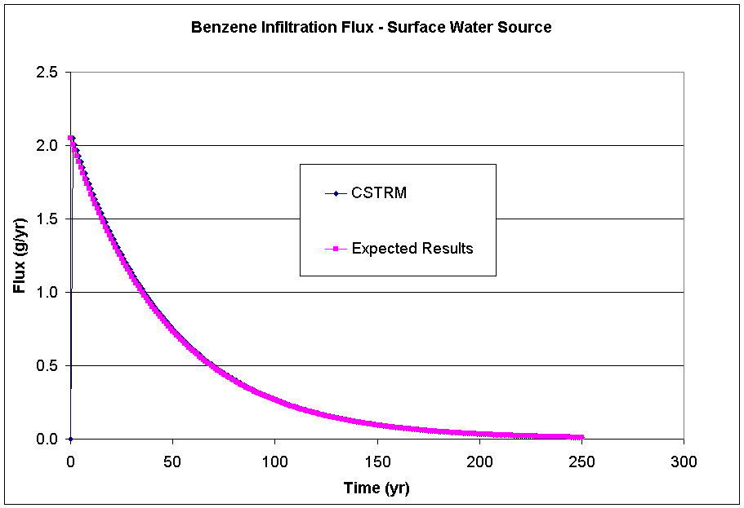
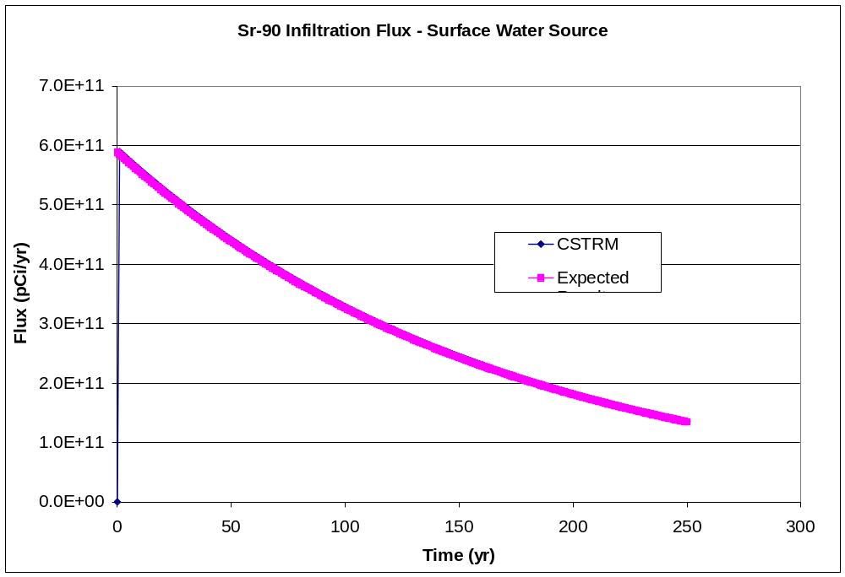
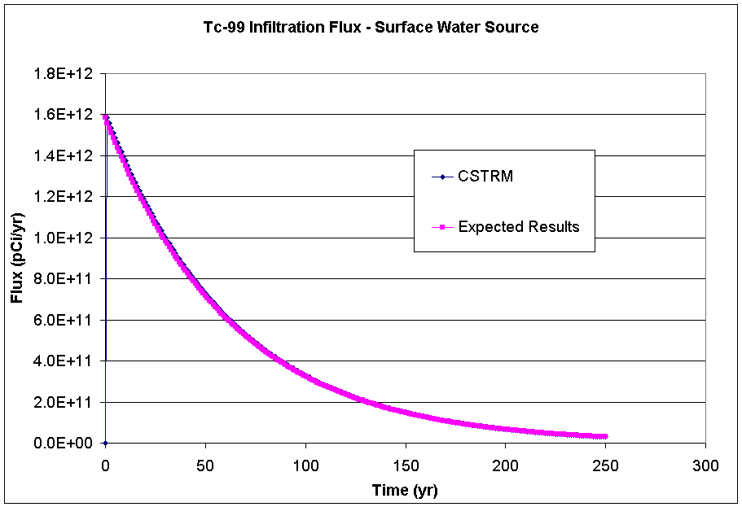

3.18b.2 Input Data

The default input data for this case is listed in Appendix B. Several changes were made to the default parameters listed. The parameter ‘source term media’ was changed to ‘surface water’, the parameter ‘overland runoff’ was changed to ‘Known discharge to ovl’, and the parameter ‘STMAXTIME’ was changed to 250 years on the Options tab. Additionally, because the source media is not surface soil anymore, different parameters are required. The input for the Release Site tab and other additional input data required are listed below.

The following table lists the input data required for the Release Site tab.

Parameter | Value | Unit
STTHICK | 1000 | cm
STLENGTH | 1000 | cm
STWIDTH | 1000 | cm
STZBULKD | 2.65 | g/cm^3
STSSOL | 0.1 | g/cm^3
STAVTEMP | 20 | C
STWINDHT | 7 | m

The following table lists the input data required for both the Kd’s and Constituent Properties tabs.

Parameter | Value | Unit
STKD (Benzene) | 0.14 | ml/g
STKD (Sr-90) | 24.3 | ml/g
STKD (Tc-99) | 3.0 | ml/g
STKD (Yt-90) | 228.0 | ml/g
STSOL (Benzene) | 1750.0 | mg/L
STSOL (Sr-90) | 1.0E+06 | mg/L
STSOL (Tc-99) | 1.0E+06 | mg/L
STSOL (Yt-90) | 1.0E+06 | mg/L
STINVEN (Benzene) | 100.0 | g
STINVEN (Sr-90) | 100.0 | Ci
STINVEN (Tc-99) | 100.0 | Ci

The following table lists the input data required for the ‘Overland’ tab.

Parameter | Value | Unit
STOVLFLO | 0.1 | m^3/yr

3.18b.3 Expected Results

It is expected that the CSTRM will mass partition all contaminants into proper phases and partition each contaminant to the overland runoff loss route while maintaining mass balance. Hand calculations were performed but are not listed here. They can be viewed along with the actual CSTRM results on the graphs in the results section.

3.18b.4 Procedure

Instructions for running this case can be found in Appendix A. As noted above, use the default parameter values provided unless otherwise instructed. An additional difference is that the contaminant database ‘FRAMES Test 12 Chemical Database Selection’ will be used instead of the ‘FRAMES Default Chemical Database Selection’. This database has been modified such that the half-life for Sr-90 is very long in order to isolate the leaching loss route from the decay loss route. The additional input data required are listed in section 3.18b.2. Attach a WFF viewer to view the results.

3.18b.5 Results

The results of interest in this test case are the mass lost to overland runoff calculated by the CSTRM. They can be found in the WFF file that can be found in the folder where the ‘tcase18b.gid’ file is located. The results from this file are graphed along with the expected results and are listed below.

Tcase18b_WFF.xls

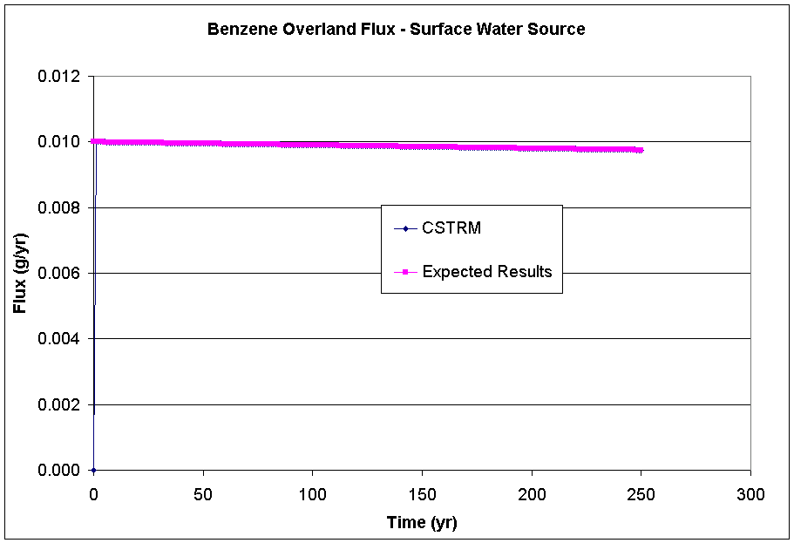
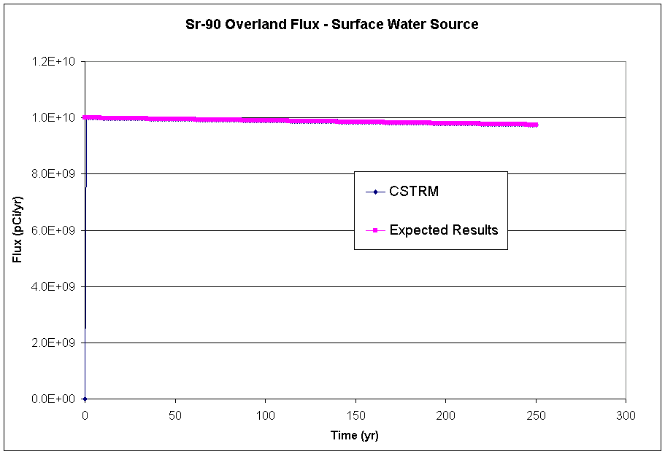
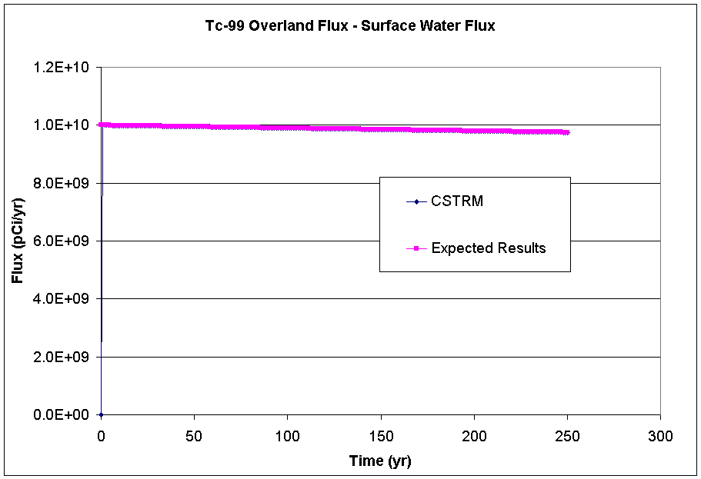

3.18c.2 Input Data

The default input data for this case is listed in Appendix B. Several changes were made to the default parameters listed. The parameter ‘source term media’ was changed to ‘surface water’, the parameter ‘volatilization’ was changed to ‘Compute Pathway’, and the parameter ‘STMAXTIME’ was changed to 250 years on the Options tab. Additionally, because the source media is not surface soil anymore, different parameters are required. The input for the Release Site tab and other additional input data required are listed below.

The following table lists the input data required for the Release Site tab.

Parameter | Value | Unit
STTHICK | 1000 | cm
STLENGTH | 1000 | cm
STWIDTH | 1000 | cm
STZBULKD | 2.65 | g/cm^3
STSSOL | 0.1 | fraction
STAVTEMP | 20 | C
STWINDHT | 7 | m

The following table lists the input data required for both the Kd’s and Constituent Properties tabs.

Parameter | Value | Unit
STKD (Benzene) | 0.14 | ml/g
STKD (Sr-90) | 24.3 | ml/g
STKD (Tc-99) | 3.0 | ml/g
STKD (Yt-90) | 228.0 | ml/g
STSOL (Benzene) | 1750.0 | mg/L
STSOL (Sr-90) | 1.0E+06 | mg/L
STSOL (Tc-99) | 1.0E+06 | mg/L
STSOL (Yt-90) | 1.0E+06 | mg/L
STINVEN (Benzene) | 100.0 | g
STINVEN (Sr-90) | 100.0 | Ci
STINVEN (Tc-99) | 100.0 | Ci
STGHALF | 0.0 | day
STVOLRAT | 1.0 | Fraction
STVOLRAT | 1.0 | Fraction
STVOLRAT | 1.0 | Fraction

3.18c.3 Expected Results

It is expected that the CSTRM will mass partition all contaminants into proper phases and partition each contaminant to the volatilization loss route while maintaining mass balance. It is expected that Sr-90 and Tc-99 will not volatilize but that benzene will. Hand calculations for all three constituents were performed but are not listed here. The benzene hand calculations can be viewed on a graph along with the actual CSTRM results in the results section.

3.18c.4 Procedure

Instructions for running this case can be found in Appendix A. As noted above, use the default parameter values provided unless otherwise instructed. An additional difference is that the contaminant database ‘FRAMES Test 12 Chemical Database Selection’ will be used instead of the ‘FRAMES Default Chemical Database Selection’. This database has been modified such that the half-life for Sr-90 is very long in order to isolate the leaching loss route from the decay loss route. The additional input data required are listed in section 3.18c.2. Attach an AFF viewer to view the results.

3.18c.5 Results

The results of interest in this test case are the mass lost to volatilization calculated by the CSTRM. They can be found in the AFF file that will be located in the folder where the ‘tcase18c.gid’ file is located. As expected, Sr-90 and Tc-99 did not volatilize. The results for benzene were graphed and are listed below along with the expected results. The values calculated compared well with the expected results.

Tcase18c_AFF.xls

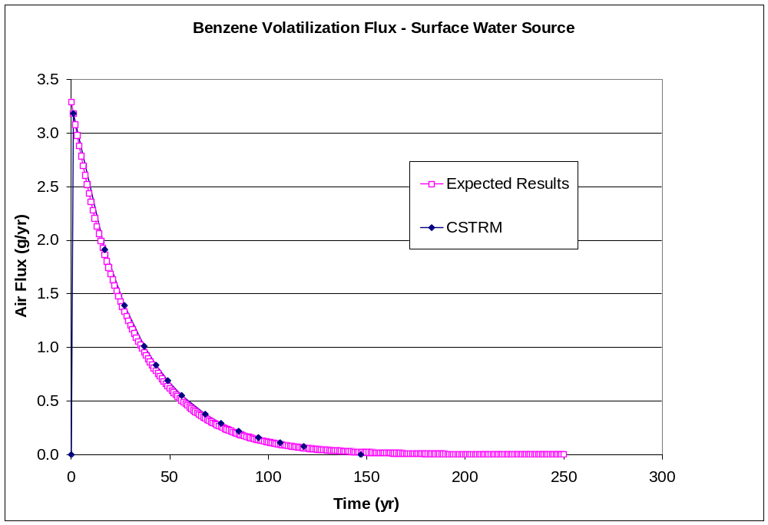

3.18d.2 Input Data

The default input data for this case is listed in Appendix B. Several changes were made to the default parameters listed. The2.6 parameter ‘source term media’ was changed to ‘surface water’, the parameter ‘leaching’ was changed to ‘Known infiltration rate’, and the parameter ‘STMAXTIME’ was changed to 250 years on the Options tab. Additionally, because the source media is not surface soil anymore, different parameters are required. The input for the Release Site tab and other additional input data required are listed below.

The following table lists the input data required for the Release Site tab.

Parameter | Value | Unit
STTHICK | 1000 | cm
STLENGTH | 1000 | cm
STWIDTH | 1000 | cm
STZBULKD | 1.5 | g/cm^3
STSSOL | 0.1 | g/cm^3
STAVTEMP | 20 | C
STWINDHT | 7 | m

The following table lists the input data required for both the Kd’s and Constituent Properties tabs.

Parameter | Value | Unit
STKD (Benzene) | 0.14 | ml/g
STKD (Sr-90) | 24.3 | ml/g
STKD (Tc-99) | 3.0 | ml/g
STKD (Yt-90) | 228.0 | ml/g
STSOL (Benzene) | 1750.0 | mg/L
STSOL (Sr-90) | 1.0E+06 | mg/L
STSOL (Tc-99) | 1.0E+06 | mg/L
STSOL (Yt-90) | 1.0E+06 | mg/L
STINVEN (Benzene) | 100.0 | g
STINVEN (Sr-90) | 100.0 | Ci
STINVEN (Tc-99) | 100.0 | Ci

The following table lists the input data required for the ‘Known Media Releases’ tab.

Parameter | Value | Unit
STDARCY | 0 | cm/yr

3.18d.3 Expected Results

It is expected that the CSTRM will correctly calculate losses of mass due to radioactive decay for Sr-90 and Tc-99 and compute no mass lost for benzene. Hand calculations were performed but are not listed here. They can be seen along with the actual CSTRM results in graphs in the results section.

3.18d.4 Procedure

Instructions for running this case can be found in Appendix A. As noted above, use the default parameter values provided unless otherwise instructed. The additional input data required are listed in section 3.18d.2.

3.18d.5 Results

The result of interest in this test case is the remaining soil concentrations calculated by the CSTRM. They can be found in the SDL file that will be located in the folder where the file ‘tcase18d.gid’ is located. As expected benzene did not decay at all. The results for Sr-90 and Tc-99 were graphed and are listed below.

Tcase18d_sdl.xls

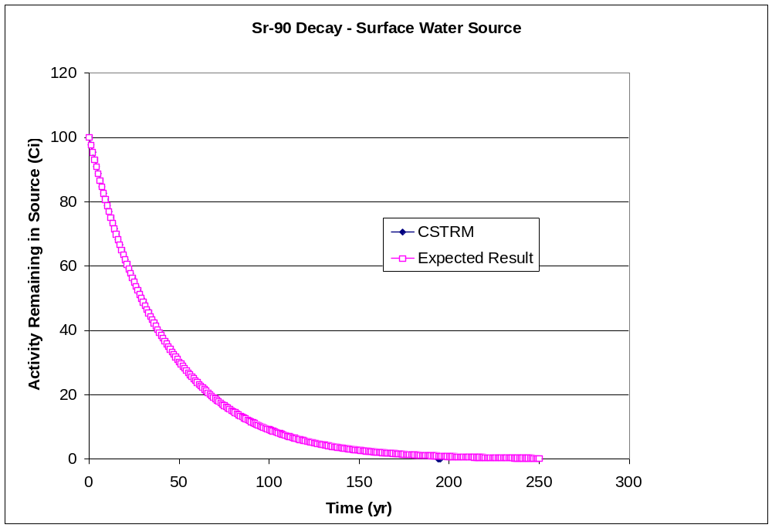

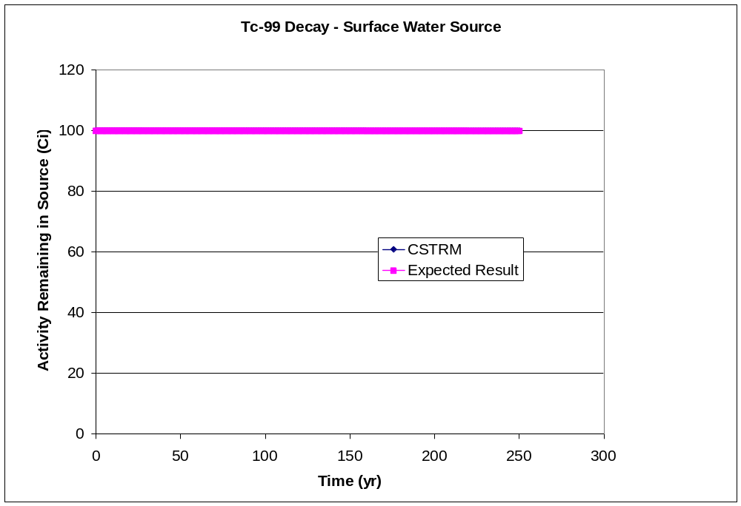

3.18e.2 Input Data

The default input data for this case is listed in Appendix B. Several changes were made to the default parameters listed. The parameter ‘source term media’ was changed to ‘surface water’, the parameters ‘leaching’, ‘overland runoff’, and ‘volatilization’ were changed from ‘Turn off pathway’ to ‘Known infiltration rate’, ‘Known discharge to overland’, and ‘Compute Pathway’ respectively, the parameter ‘STMAXTIME’ was changed to 250 years, and the parameter ‘STMINWST’ was changed to 0.0002 on the Options tab. Additionally, because the source media is not surface soil anymore, different parameters are required. The input for the Release Site tab and other additional input data required are listed below.

The following table lists the input data required for the Release Site tab.

Parameter | Value | Unit
STTHICK | 1000 | cm
STLENGTH | 1000 | cm
STWIDTH | 1000 | cm
STZBULKD | 2.65 | g/cm^3
STSSOL | 0.1 | g/cm^3
STAVTEMP | 20 | C
STWINDHT | 7 | m

The following table lists the input data required for both the Kd’s and Constituent Properties tabs.

Parameter | Value | Unit
STKD (Benzene) | 0.14 | ml/g
STKD (Sr-90) | 24.3 | ml/g
STKD (Tc-99) | 3.0 | ml/g
STKD (Yt-90) | 228.0 | ml/g
STSOL (Benzene) | 1750.0 | mg/L
STSOL (Sr-90) | 1.0E+06 | mg/L
STSOL (Tc-99) | 1.0E+06 | mg/L
STSOL (Yt-90) | 1.0E+06 | mg/L
STINVEN (Benzene) | 100.0 | g
STINVEN (Sr-90) | 100.0 | Ci
STINVEN (Tc-99) | 100.0 | Ci
STVOLRAT (Benzene) | 1.0 | fraction
STVOLRAT (Sr-90) | 1.0 | fraction
STVOLRAT (Tc-99) | 1.0 | fraction

The following table lists the input data required for the ‘Known Media Releases’ tab.

Parameter | Value | Unit
STDARCY | 20 | cm/yr

The following table lists the input data required for the ‘Overland’ tab.

Parameter | Value | Unit
STOVLFLO | 0.1 | m^3/yr

3.18e.3 Expected Results

It is expected that the CSTRM will mass partition all contaminants into proper phases and partition each contaminant to the each loss route while maintaining mass balance. Hand calculations were performed but are not listed here. They can be seen along with the actual CSTRM results in graphs in the results section.

3.18e.4 Procedure

Instructions for running this case can be found in Appendix A. As noted above, use the default parameter values provided unless otherwise instructed. The additional input data required are listed in section 3.18c.2.

3.18e.5 Results

The results of interest in this test case are the contaminant masses remaining in the source as computed by the CSTRM. They can be found in the SDL file that will be located in the folder where the file ‘tcase18e.gid’ is located. The results were graphed and are listed below.

Tcase18e_SDL.xls

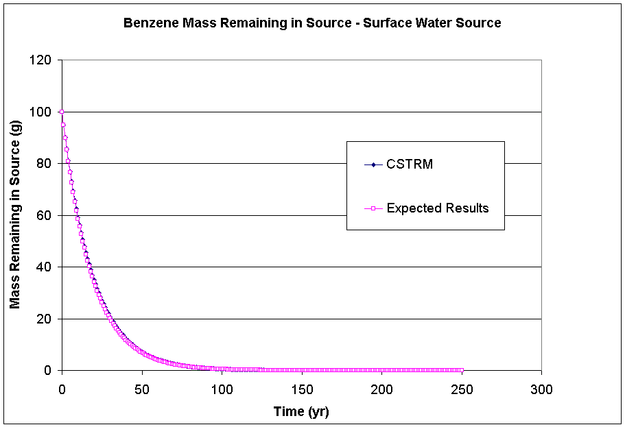
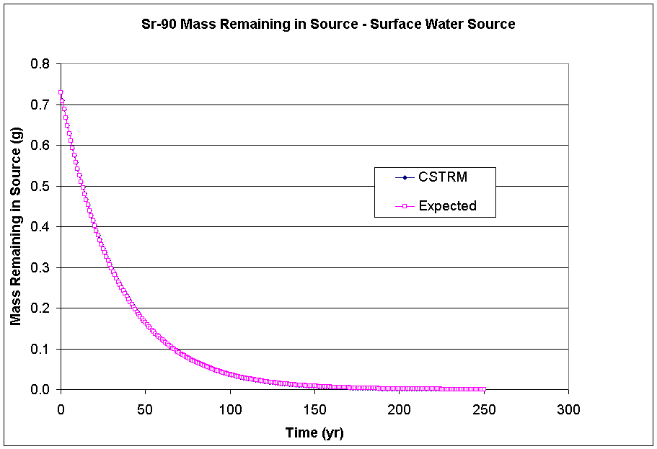
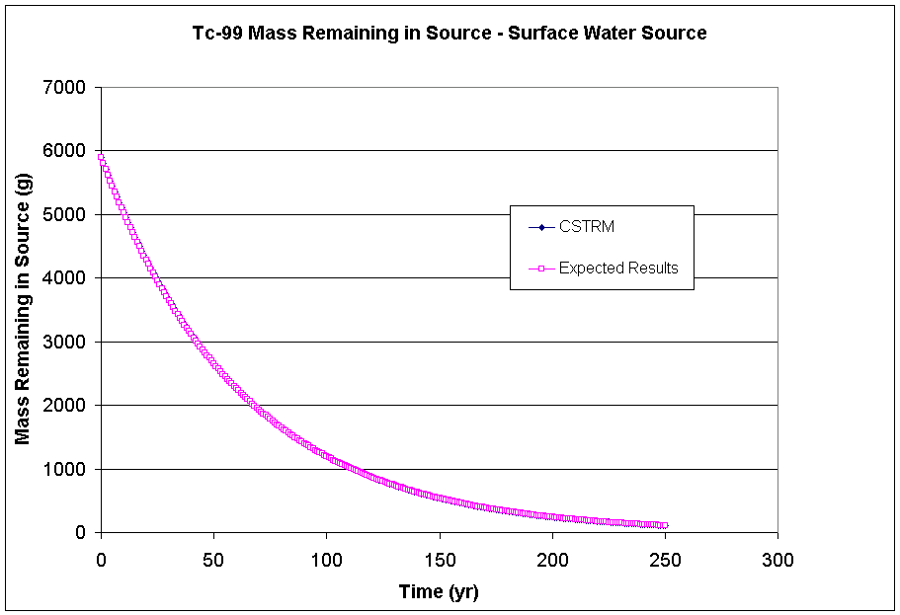

3.19 Tcase19

3.19.1 Description and Rationale

This case verifies that the CSTRM will allow the user to select up to 25 contaminants to be evaluated in a single run. Organic, inorganic, and radionuclide constituents were selected and are listed in the following section. The source media is surface soils and leaching was the only transport pathway. The option to have constituents decay in the source was selected to test the CSTRM’s ability to account for the decay products in addition to the 25 constituents initially selected.

This case will also be used to verify that the model is capable of outputting time-varying infiltration rates in the *.WFF file.

3.19.2 Input Data

The default input data for this case is listed in Appendix B. Several changes were made to the default parameters listed. The parameter ‘leaching loss route’ was changed to ‘Known infiltration rate’ and ‘STMAXTIME’ was changed to 10 years on the Options tab. Additional input data required are listed below.

The following table lists the input data required for Constituent Properties tabs.

Constituent | Kd (ml/g) | Solubility (mg/L) | Inventory
(E)-1,2-dichloropropane | 0 | 1.0E+06 | 100 g
1,1 dichloroethylene | 0 | 1.0E+06 | 100 g
1,1,1,2-Tetrachloroethane | 0 | 1.0E+06 | 100 g
1,1,2-Trichoroethane | 0 | 1.0E+06 | 100 g
1,2 Dichlorobenzene | 0 | 1.0E+06 | 100 g
1,2,3-Trichloropropane | 0 | 1.0E+06 | 100 g
1,2,5,6-DBA | 0 | 1.0E+06 | 100 g
1,2-benzanthracene | 0 | 1.0E+06 | 100 g
Benzene | 0 | 1.0E+06 | 100 g
Sodium Oxalate | 0 | 1.0E+06 | 100 g
Sodium-22 | 0 | 1.0E+06 | 100 Ci
Sodium-24 | 0 | 1.0E+06 | 100 Ci
Strontium-85 | 0 | 1.0E+06 | 100 Ci
Stronium-89 | 0 | 1.0E+06 | 100 Ci
Stronium-90 | 0 | 1.0E+06 | 100 Ci
Strontium-91 | 0 | 1.0E+06 | 100 Ci
Uranium-232 | 0 | 1.0E+06 | 100 Ci
Uranium-233 | 0 | 1.0E+06 | 100 Ci
Uranium-234 | 0 | 1.0E+06 | 100 Ci
Uranium-235 | 0 | 1.0E+06 | 100 Ci
Uranium-236 | 0 | 1.0E+06 | 100 Ci
Uranium-237 | 0 | 1.0E+06 | 100 Ci
Uranium-238 | 0 | 1.0E+06 | 100 Ci
Uranium-239 | 0 | 1.0E+06 | 100 Ci
Uranium-240 | 0 | 1.0E+06 | 100 Ci
A solubility of 1.0E+06 mg/L was assigned to all decay products

The following table lists the input data required for the ‘Known Media Releases’ tab.

Parameter | # of measurements | Value | Year
STDARCY | 3 | 20 cm/yr | 0
 |  | 22 cm/yr | 5
 |  | 30 cm/yr | 10

3.19.3 Expected Results

It is expected that the CSTRM will produce mass fluxes for each of the 25 constituents selected as well as mass fluxes for any decay products that may form.

It is also expected that the time-varying infiltration rates will be written to the *.WFF file.

3.19.4 Procedure

Instructions for running this case can be found in Appendix A. As noted above, use the default parameter values provided unless otherwise instructed. The additional input data required are listed in section 3.19.2. Attach a WFF viewer to view the results.

3.19.5 Results

The results of interest in this test case are the mass flux lost to infiltration calculated by the CSTRM. They can be found in the WFF file that will be located in the folder where the *.GID file for this case is located. The file is listed below and it did contain mass fluxes for all 25 constituents selected as well as for all decay products generated. It also listed time-varying infiltration rates starting at the 15th line in the file.

"src2",503
7
"================================================================================"
" Source Term Release Module Version: Framework PoP January 1997 "
" Run:","c:\frames\tcase19\(tmp)"
" Site:","src2"
" Run Performed:","11/3/2003","13:32:53"
" Output Filename:","c:\frames\tcase19\(tmp).wff"
"================================================================================"
1
"All","Vadose",10,"m",10,"m",0,"m",0.3000000119,"m/yr",23
"yr","m^3/yr",3
0,20
5,22
10,30
"1,1 dichloroethylene","75354","yr","g/yr",3 ,1,0
0,0
1,100
2,0
"1,1,1,2-Tetrachloroethane","630206","yr","g/yr",3 ,1,0
0,0
1,100
2,0
"1,1,2-Trichloroethane","79005","yr","g/yr",3 ,1,0
0,0
1,100
2,0
"1,2 Dichlorobenzene","95501","yr","g/yr",3 ,1,0
0,0
1,100
2,0
"1,2,3-Trichloropropane","96184","yr","g/yr",3 ,1,0
0,0
1,100
2,0
"1,2,5,6-DBA","53703","yr","g/yr",11 ,1,0
0,0
1,0.01000000071
2,0.01020000037
3,0.01040000003
4,0.01060000062
5,0.01080000028
6,0.01100000087
7,0.01180000044
8,0.01260000095
9,0.01340000052
10,0.01420000009
"1,2-benzanthracene","56553","yr","g/yr",11 ,1,0
0,0
1,0.0130034741
2,0.1917599887
3,0.1955199838
4,0.1992799789
5,0.2030400038
6,0.2067999989
7,0.2218399942
8,0.2368799746
9,0.251919955
10,0.266959995
"1,2-Dichloropropane","78875","yr","g/yr",3 ,1,0
0,0
1,100
2,0
"Benzene","71432","yr","g/yr",3 ,1,0
0,0
1,100
2,0
"Sodium Oxalate","62760","yr","g/yr",11 ,1,0
0,0
1,8
2,7.526603699
3,7.067182064
4,6.622744083
5,6.19412756
6,5.782005787
7,5.661872864
8,5.483545303
9,5.255681038
10,4.987309933
"STRONTIUM-85","SR85","yr","pCi/yr",3 ,1,0
0,0
1,2.006533538e+12
2,0
"STRONTIUM-89","SR89","yr","pCi/yr",3 ,1,0
0,0
1,1.570688729e+12
2,0
"STRONTIUM-90","SR90","yr","pCi/yr",11 ,1,1
0,0
1,7.999999967e+12
2,7.348969538e+12
3,6.737535435e+12
4,6.164816855e+12
5,5.629758407e+12
6,5.13115947e+12
7,4.905965715e+12
8,4.639308644e+12
9,4.341584101e+12
10,4.022657876e+12
"YTTRIUM-90","Y90","yr","pCi/yr",11 ,1,"STRONTIUM-90","SR90"
0,0
1,0
2,7.741698474e+12
3,7.103248335e+12
4,6.504625209e+12
5,5.944813027e+12
6,5.422634238e+12
7,5.196948701e+12
8,4.93019988e+12
9,4.628585906e+12
10,4.302327251e+12
"STRONTIUM-91","SR91","yr","pCi/yr",3 ,1,1
0,0
1,1.25116672e+10
2,0
"Yttrium-91","Y91","yr","pCi/yr",4 ,1,"STRONTIUM-91","SR91"
0,0
1,0
2,1.252612301e+10
3,0
"URANIUM-232","U232","yr","pCi/yr",11 ,1,3
0,0
1,7.999999443e+12
2,7.454499799e+12
3,6.932425343e+12
4,6.434226962e+12
5,5.960161559e+12
6,5.510307774e+12
7,5.344128926e+12
8,5.12622592e+12
9,4.866141323e+12
10,4.573425566e+12
"THORIUM-228","TH228","yr","pCi/yr",11 ,1,"URANIUM-232","U232"
0,0
1,0
2,2.875753497e+12
3,4.556672467e+12
4,5.459466519e+12
5,5.860294656e+12
6,5.941703475e+12
7,6.124692046e+12
8,6.125767361e+12
9,5.988616241e+12
10,5.749038121e+12
"RADIUM-224","RA224","yr","pCi/yr",11 ,1,"URANIUM-232","U232"
0,0
1,0
2,0
3,2.405885805e+12
4,3.807819858e+12
5,4.557114442e+12
6,4.886255632e+12
7,5.209743426e+12
8,5.329101783e+12
9,5.292271075e+12
10,5.139544408e+12
"LEAD-212","PB212","yr","pCi/yr",11 ,1,"URANIUM-232","U232"
0,0
1,0
2,0
3,0
4,2.590569923e+12
5,4.098649227e+12
6,4.903477969e+12
7,5.537400357e+12
8,5.876793999e+12
9,5.987133555e+12
10,5.924496867e+12
"URANIUM-233","U233","yr","pCi/yr",11 ,1,3
0,0
1,7.999999967e+12
2,7.526573146e+12
3,7.067123843e+12
4,6.622662361e+12
5,6.194025464e+12
6,5.781886337e+12
7,5.661732635e+12
8,5.483387159e+12
9,5.255508001e+12
10,4.987124974e+12
"THORIUM-229","TH229","yr","pCi/yr",11 ,1,"URANIUM-233","U233"
0,0
1,0
2,753565376
3,1415640192
4,1990630912
5,2483284992
6,2898610432
7,3408200448
8,3854466048
9,4226580736
10,4517462016
"RADIUM-225","RA225","yr","pCi/yr",11 ,1,"URANIUM-233","U233"
0,0
1,0
2,0
3,747080448
4,1401701888
5,1968592768
6,2452787200
7,3009539072
8,3509983488
9,3939688960
10,4289529856
"ACTINIUM-225","AC225","yr","pCi/yr",11 ,1,"URANIUM-233","U233"
0,0
1,0
2,0
3,0
4,758905408
5,1423291776
6,1998102912
7,2621397248
8,3200831744
9,3717100032
10,4156244224
"URANIUM-234","U234","yr","pCi/yr",11 ,1,6
0,0
1,7.999999443e+12
2,7.526584156e+12
3,7.067145863e+12
4,6.62269277e+12
5,6.194064261e+12
6,5.781930902e+12
7,5.661785063e+12
8,5.483446403e+12
9,5.255572488e+12
10,4.98719418e+12
"THORIUM-230","TH230","yr","pCi/yr",11 ,1,"URANIUM-234","U234"
0,0
1,0
2,71864992
3,135010688
4,189856240
5,236853360
6,276478720
7,325099200
8,367683200
9,403197152
10,430964576
"RADIUM-226","RA226","yr","pCi/yr",11 ,1,"URANIUM-234","U234"
0,0
1,0
2,0
3,31035.48242
4,87309.09375
5,163425.5
6,254422.2969
7,374154.8125
8,508207.375
9,650813.375
10,795879.8125
"RADON-222","RN222","yr","pCi/yr",11 ,1,"URANIUM-234","U234"
0,0
1,0
2,0
3,0
4,30844.90234
5,86671.58594
6,162044.8438
7,265257.2188
8,387037.375
9,521891.1562
10,663801.125
"LEAD-210","PB210","yr","pCi/yr",11 ,1,"URANIUM-234","U234"
0,0
1,0
2,0
3,0
4,0
5,1032.031738
6,3832.828857
7,9346.823242
8,18076.93945
9,30312.79492
10,46046.78125
"BISMUTH-210","BI210","yr","pCi/yr",11 ,1,"URANIUM-234","U234"
0,0
1,0
2,0
3,0
4,0
5,0
6,989.7736816
7,3865.008057
8,9351.44043
9,17954.39453
10,29902.55859
"POLONIUM-210","PO210","yr","pCi/yr",11 ,1,"URANIUM-234","U234"
0,0
1,0
2,0
3,0
4,0
5,0
6,0
7,1009.797241
8,3912.094482
9,9396.137695
10,17916.85547
"URANIUM-235","U235","yr","pCi/yr",11 ,1,5
0,0
1,7.999999967e+12
2,7.526605652e+12
3,7.06718466e+12
4,6.622748869e+12
5,6.194133991e+12
6,5.78201269e+12
7,5.661881008e+12
8,5.483554931e+12
9,5.255690977e+12
10,4.987321582e+12
"THORIUM-231","TH231","yr","pCi/yr",11 ,1,"URANIUM-235","U235"
0,0
1,0
2,7.973116051e+12
3,7.492463493e+12
4,7.026933498e+12
5,6.577448813e+12
6,6.144767558e+12
7,6.031575876e+12
8,5.860465574e+12
9,5.635094086e+12
10,5.364651131e+12
"PROTACTINIUM-231","PA231","yr","pCi/yr",11 ,1,"URANIUM-235","U235"
0,0
1,0
2,0
3,171512464
4,321836512
5,452050432
6,563303424
7,690656768
8,804769152
9,902803968
10,982671360
"ACTINIUM-227","AC227","yr","pCi/yr",11 ,1,"URANIUM-235","U235"
0,0
1,0
2,0
3,0
4,5434298.5
5,15108875
6,27952014
7,45239132
8,65222952
9,86909312
10,109255336
"THORIUM-227","TH227","yr","pCi/yr",11 ,1,"URANIUM-235","U235"
0,0
1,0
2,0
3,0
4,0
5,5191615
6,14416190
7,28033076
8,44999384
9,64383640
10,85178360
"RADIUM-223","RA223","yr","pCi/yr",11 ,1,"URANIUM-235","U235"
0,0
1,0
2,0
3,0
4,0
5,0
6,5361358
7,15675401
8,30332868
9,48480876
10,69097792
"URANIUM-236","U236","yr","pCi/yr",11 ,1,0
0,0
1,8.000000492e+12
2,7.526605652e+12
3,7.06718466e+12
4,6.622748869e+12
5,6.194133467e+12
6,5.782012166e+12
7,5.661880484e+12
8,5.483553882e+12
9,5.255689929e+12
10,4.987320009e+12
"Uranium-237","U237","yr","pCi/yr",3 ,1,0
0,0
1,2.128397435e+11
2,0
"URANIUM-238","U238","yr","pCi/yr",11 ,1,8
0,0
1,6.732999295e+12
2,6.867659522e+12
3,7.002319749e+12
4,6.728137572e+12
5,6.292702233e+12
6,5.874023137e+12
7,5.751979901e+12
8,5.570815853e+12
9,5.339325399e+12
10,5.066685678e+12
"THORIUM-234","TH234","yr","pCi/yr",11 ,1,"URANIUM-238","U238"
0,0
1,0
2,7.956418527e+12
3,7.53461153e+12
4,7.082558358e+12
5,6.628559028e+12
6,6.191621079e+12
7,6.074058408e+12
8,5.898341188e+12
9,5.668243243e+12
10,5.393102143e+12
"URANIUM-234","U234","yr","pCi/yr",11 ,1,"URANIUM-238","U238"
0,0
1,0
2,0
3,22999322
4,43324860
5,60979252
6,76062344
7,93312136
8,108760808
9,122025008
10,132823032
"THORIUM-230","TH230","yr","pCi/yr",11 ,1,"URANIUM-238","U238"
0,0
1,0
2,0
3,0
4,206.1244049
5,580.6242065
6,1087.253418
7,1779.864746
8,2594.420898
9,3494.094727
10,4438.461426
"RADIUM-226","RA226","yr","pCi/yr",11 ,1,"URANIUM-238","U238"
0,0
1,0
2,0
3,0
4,0
5,0.08881168813
6,0.3327541947
7,0.8177599311
8,1.590953708
9,2.680930138
10,4.090384483
"RADON-222","RN222","yr","pCi/yr",11 ,1,"URANIUM-238","U238"
0,0
1,0
2,0
3,0
4,0
5,0
6,0.08806137741
7,0.3469249904
8,0.8459162116
9,1.633791089
10,2.734431267
"LEAD-210","PB210","yr","pCi/yr",11 ,1,"URANIUM-238","U238"
0,0
1,0
2,0
3,0
4,0
5,0
6,0
7,0.003102177521
8,0.01507768221
9,0.04355205595
10,0.09691952169
"BISMUTH-210","BI210","yr","pCi/yr",11 ,1,"URANIUM-238","U238"
0,0
1,0
2,0
3,0
4,0
5,0
6,0
7,0
8,0.003103709547
9,0.01497547049
10,0.04296264797
"POLONIUM-210","PO210","yr","pCi/yr",11 ,1,"URANIUM-238","U238"
0,0
1,0
2,0
3,0
4,0
5,0
6,0
7,0
8,0
9,0.003118544351
10,0.01494416501
"URANIUM-239","U239","yr","pCi/yr",3 ,1,0
0,0
1,515062208
2,0
"Uranium-240","U240","yr","pCi/yr",3 ,1,0
0,0
1,1.857680384e+10
2,0

Appendix A

General Instructions For Setting Up And Running Test Cases

The MEPAS CSTRM must be run using the FRAMES (Framework for Risk Analysis in Multimedia Environmental Systems) software system. These instructions assume that the FRAMES user interface is up on the user’s computer.

Each test case must include a minimum of two modules: a contaminant database and the CSTRM. Additional modules can be added to view output result files, but they are not required for test case execution.

To start a new case, click on the contaminant selection icon. The icon should appear in the worksheet section of the screen along with a signal light that will be black. The black light indicates that a contaminant database has not been selected. Once the database has been selected, the light will turn red indicating that a database has been selected but no contaminants have been selected. Once the database and contaminants are selected, the light will turn green indicating that the module has been completed. Double click on the contaminants icon. A screen titled ‘Object General Information’ will appear. The section titled ‘Select from Model List’ contains a list of databases that can be used in the FRAMES system. Single click on the FRAMES Default Chemical Database Selection. A description will appear in the ‘Model Description’ section to the right. Then click ‘ok’ at the bottom of the screen. You will then be prompted to provide a name and select a location for the file. When done entering a file name and selecting a file location, click ‘ok’ at the bottom of the screen. A new screen titled ‘Contaminant Selection’ will appear. The contaminants of interest must be chosen using this screen. Several categories of contaminants may be chosen. The default category is ‘All Contaminants’. The other categories may be selected by single clicking on the button to the right of the ‘Select from Possible Contaminants:’ box. The contaminants selected for all test cases were chosen from the ‘All Contaminants’ list.
To select a contaminant, click on the ‘Find’ button, type in the contaminant name, and click ‘ok’. The first contaminant containing the contaminant name will be highlighted in the list to the right. For example, if you typed in ‘benzene’, ‘1,2 Dichlorobenzene’ would be highlighted because it contains the word string ‘benzene’. Since it is not the contaminant of interest, you would click on ‘Again’ and the next contaminant containing ‘benzene’ would be highlighted. You would continue to click ‘ok’ until plain ‘benzene’ was highlighted. You would then click on ‘Select’ and it would be added to the list of contaminants that will be used, which is located to the right. Additional contaminants can be added by following the same process. A contaminant may be removed from the list by highlighting the contaminant in the list to the right and clicking ‘Remove’. When the list is complete, click ‘ok’. The contaminant selection screen will disappear and the signal light attached to the Contaminants icon will change to green instead of red indicating that contaminant selection is complete.
The next step is to select a source term module. To do this, single click on the source term icon and drag it into the worksheet area to the location that you want it. The source term icon will appear along with a signal light which will be black. The black light indicates that a source term model has not been chosen. Once the source term module has been selected, the signal light will turn red indicating that a model has been chosen but that the required data has not been entered or the data entered is incomplete. Once the data has been entered properly, the light will turn yellow indicating that the module has been completed and is ready to be executed. Double click on the source term icon. A screen titled ‘Object General Information’ should appear. In the box titled ‘Label:’, type in a source module name. Then select a source term module from the list in the ‘Select from Applicable Models’ list box on the left. All tests were performed using the ‘MEPAS 4.0 Computed Contaminant Emissions’ source term module. Single click on this module and click ‘ok’ at the bottom of the screen. The ‘Object General Information’ screen will disappear and the user interface for the source term module will appear. At this time, enter all of the required data. All default test data is located in Appendix B. Test data specific to each test case will be specified in each test case description. When all of the required input data have been entered, use the ‘File’ pull-down menu to select ‘Save Changes and Exit’. If any of the required data was not entered, an error message box will appear and the signal light will remain red. If this happens, right click on the source term icon, and select ‘User Input’. The user interface for the source term module will reappear. Look for the parameter that has a red box where the parameter value should be. Type in an acceptable value and save and exit again. Upon exiting, the signal light will now turn yellow indicating that the source term module may be executed. Double click on the source term icon to execute the module. The module will run and a DOS window will appear. Once it is finished, close down the DOS window. The signal light will now be green indicating that the module ran successfully.
The results may be found in the output files with the extensions .AFF, .WFF, .WCF. and .SCF. The results can be viewed in FRAMES by using one of the viewers. To use the viewer, single click on the graph icon and drag it into the worksheet area near the source term icon. Hold down the shift key and left mouse button and drag a line from the source term icon to the graph icon. A line with an arrow pointing to the viewer will appear. Double click on the chart icon. The ‘Object General Information’ screen will appear. In the box titled ‘Label:’, type in a viewer name. Then select what type of viewer you would like from the list in the ‘Select from Applicable Models’ list box on the left. If you are expecting water fluxes to be produced, highlight the WFF viewer. If you are expecting air fluxes to be produced, highlight the AFF viewer. If you are interested in soil concentrations at the source, highlight the SCF viewer. After one of the modules is selected, click ‘ok’ at the bottom of the screen. The ‘Object General Information’ screen will close down. Then right click on the viewer icon and select ‘Run Model’. The viewer will display the file type that you choose. Close the window when you are finished with it. You can add all three viewers to the same source, by repeating the above process and selecting different viewer types. It is important to note that these viewers are not necessary. The results may be viewed using DOS, M.S. Excel, NotePad, and by other similar software packages.

Appendix B

Default Input Parameter Values For All Test Cases

The following values will be used in all test cases unless otherwise specified in individual test case descriptions. In the CSTRM Modular User Interface (MUI), input parameters are grouped into separate tabs according to their subject area. For example, contaminant data and release site input data are requested on separate tabs. The default parameter values presented in this appendix are separated into tables by these tab names.
It should be noted that not all tabs and parameters are presented here. The MUI determines which tabs are active by the parameters chosen by the user. The parameters requested on each tab might also change depending on user input. For example, if the user does not specify suspension as a contaminant pathway, then the suspension tab will not be active. Any additional input parameter values that are required for a test case will be presented in the description of the specific test case.

Tab Name: Options
Description | Parameter Name | Parameter Value | Unit
Source term media | STMEDIA | Soil | none
Leaching | STINF_OP | Turn off pathway | none
Overland runoff | STOVL_OP | Turn off pathway | none
Suspension | STSUS_OP | Turn off pathway | none
Volatilization | STVOL_OP | Turn off pathway | none
Source/sink | STSRC_OP | Turn off pathway | none
Time interval for first 100 yrs | STDELTA_T | 1 | years
Length of run | STMAXTIME | 50 | years
Minimum waste fraction | STMINWST | 0.001 | fraction

Tab Name: Waste Zone
Description | Parameter Name | Parameter Value | Unit
Depth to top of waste zone | STCLEAN | 0
Thickness of waste zone | STTHICK | 1000 | cm
Length of waste zone | STLENGTH | 1000 | cm
Width of waste zone | STWIDTH | 1000 | cm
Bulk density of soil | STZBULKD | 1.5 | g/cm3
Total porosity | STTOTPOR | 50 | percent
Moisture content | STMOISTC | 25 | percent
Volumetric air content | STAIRSPC | 25 | percent
Average air temperature at the waste site | STAVTEMP | 20 | C
Mean annual wind speed | STAVWINDV | 10.0 | mi/hr
Height above ground of local wind measure | STWINDHT | 7 | meters

The following table lists the input parameters for the ‘Soil Triangle’ window. It is used to obtain input data required to provide estimated Kd values. This window only appears if the ‘Soil Properties’ button is pushed on the ‘Kd’s’ tab. If the estimated kd’s are not used, this data does not need to be entered.

Window Name: Soil Triangle
Description | Parameter Name | Parameter Value | Unit
% sand | KD-SAND | 83 | %
% silt | KD-SILT | 11 | %
% clay | KD-CLAY | 6 | %
% organic matter | KD-OMC | 0 | %
% iron and aluminum | KD-IRON | 0 | %
pH of soil | KD-PH | 7 | none

